Flow Design of Sewerage System – A Case Study in Taman Pandan Damai, Kuantan

A. Su Kong Ngien^{1,2*}, B. Yap Hiew Thong¹

¹ Faculty of Civil Engineering & Earth Resources, ² Centre for Earth Resources and Management, Universiti Malaysia Pahang (CERRM)
*Corresponding author: yap9636@hotmail.com

Abstract
Malaysian sewerage systems are designed according to the Malaysian Standard MS 1228:1991. Manholes may be flooded and overflow if the peak flow of sewage is not properly addressed during sewerage system design. The purpose of the overall research is to analyse the per capita flow as well as design criterion in the sewerage systems within Kuantan, Pahang and compare them to their counterpart in the MS 1228:1991. This study was conducted in a residential area,Taman Pandan Damai. Population equivalent in the area was surveyed as 2244PE. ISCO 4250 Area Velocity Flowmeter was used to collect real time flowrate data using an Area Velocity Sensor. Based on the results obtained the average per capita flow and design criterion was lower than the 0.225m³/day/person and 4.7 stated in MS 1228:1991, respectively. This indicated that the design of the sewerage system in Taman Pandan Damai was more than capable of catering to the PE serviced in that area.

Key words: Per capita flow, Design criterion, Flowmeter, Sewerage system

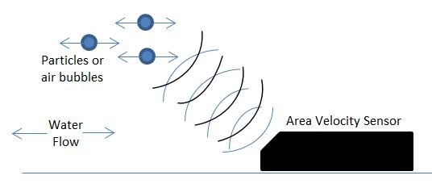
Fig. 1. Ultrasonic technology of Area Velocity sensor

