Journal of Engineering and Applied Sciences
ISSN : 1816-949x
Medwell Journals, 2017

A POTENTIAL DEVELOPMENT OF HAZE DETECTION SYSTEM
USING AN OPEN-PATH OPTICAL METHOD

S. Nurulain¹, M.S. Najib¹, MH Alsibai¹, MR Mohamed¹, M. R. Salim², H. Manap¹
¹University of Malaysia Pahang (UMP), Malaysia
²University of Technology Malaysia (UTM), Malaysia
Email: ainnadhirah93@gmail.com

Abstract: This paper describes a potential development of haze measurement system by measuring visibility of a medium instead of measuring concentration of particulate matter in air. This measurement system is using an open path optical method to measure visibility of a few series of known-VLT thin film. VLT or visible light transmission rate plays an important role in order to determine the visibility of a medium and can be an alternative method to determine the haze index. Current instrument to measure haze is very big in size and cost too expensive relatively. Therefore an alternative method using a laser pointer as a light source and a spectrometer as a detector is introduced. The result shows that the measurement system is capable to measure a few series of known-VLT thin film within the visible light region (535-540 nm). It shows that this measurement system is capable to measure the visibility of haze and the response time is less than 1 s is reported.

Keywords: Optical sensor, haze detection, open-path method

Introduction
Haze occurs when dust or smoke particles accumulate in open air. When these smoke and other pollutants are not dispersed by wind or other weather condition, they concentrate and form a usually low-hanging shroud that weakens visibility. The haze may become a health threat especially to human respiratory system. In Malaysia, haze is caused by open burning either by local or from neighbour country. Lingering smoke from forest fires on the Indonesian island of Sumatra are identified as the primary cause (BBC News, 2015). Farmers regularly burn scrub and forest to clear land during the dry season for agricultural purposes and these activities worsen the air quality.

In order to measure air quality, Singapore and Indonesia use the Pollutants Standards Index (PSI), while Malaysia uses the similar Air Pollutants Index (API). On both indices, a reading that is above 100 is classified as unhealthy and anything above 300 is hazardous. (BBC News, 2015). However there is a slight difference on the way of the indices are calculated and the values range from country to country. According to Malaysian Department of Environment (DOE) official website, the Malaysian API system closely follows the Pollutant Standard Index (PSI) developed by the United States Environmental Protection Agency (US-EPA). API for a given time period is determined by measuring the concentration of all five air pollutants which are SO₂, NOx, CO, PM₁₀, and O₃. The maximum of all five pollutants is selected as the API and the specific responsible air pollutants for the API value has to be reported to indicate the relevant health effect category (DOE, 2015). Normally PM₁₀ is selected as this is the main contributor to the haze in Malaysia due to flying ash of the open burning. Concentration of PM₁₀ is normally determined using an instrument called high volume sampler (Li et al, 2008: Dotse et al, 2016: Show & Chang, 2013). However this instrument is too big and cost too expensive relatively. It is also time consuming to have the reading of PM₁₀ concentration because it uses filter weighing method. Therefore, a new method by measuring air visibility is going to be introduced as an alternative method for measuring haze index. Visibility is a measure of the distance at which an object or light can be clearly detected (Xie et al, 1999). Visibility information is essential in dust and air quality monitoring which often require frequent and accurate real-time observations (O’Loingsigh et al, 2010).
The measurement of visibility can be identified by referring to the amount of visible light transmission (VLT). As the percentage of VLT increase, light intensity will also increase. Thus, the visibility will also increase. VLT simply refers to the measurable amount of solar visible light (daylight) that travels through a certain medium. A medium with a high VLT allows most of the daylight to pass through while a lower VLT restricts the majority of light from entering a medium.

In this paper, a new optical method by using a laser pointer as a light source to develop the VLT measurement system as a new potential method to measure haze is reported. This new technique is believed to cater the problem mentioned above as the experimental set-up is small in size and low cost relatively. It is also believed that using an optical method can yield a fast result of haze measurement and real time monitoring can be implemented.

Theory

The measurement of visibility can be identified by referring to the amount of visible light transmission (VLT). As the percentage of VLT increase, light intensity will also increase. Thus, the visibility will also increase. VLT simply refers to the measurable amount of solar visible light (daylight) that travels through a certain medium. A medium with a high VLT allows most of the daylight to pass through while a lower VLT restricts the majority of light from entering a medium.

In this paper, a new optical method by using a laser pointer as a light source to develop the VLT measurement system as a new potential method to measure haze is reported. This new technique is believed to cater the problem mentioned above as the experimental set-up is small in size and low cost relatively. It is also believed that using an optical method can yield a fast result of haze measurement and real time monitoring can be implemented.

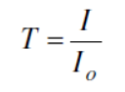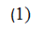
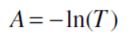

Using this equation, the absorption of light that passed through the air can be determined if the incident and the transmitted intensity are known.

Experimental setup

The experimental setup is shown in Figure 3. It is called an open path system and has been reported in many papers (Mohamad et al, 2014: Manap et al, 2009: Xia et al, 2008). Since the experiment is conducted in a laboratory, there are a few limitations which need to be considered.
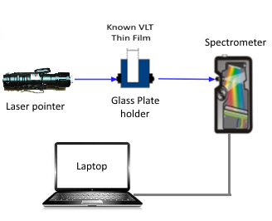
Figure 3: Experimental setup

The path length between light source and detector which is limited relative to on site measurement is restricted to 100 cm. The changes of room light intensity during the experiment is carried out is also ignored. The laser pointer also produce a beam which has unstable intensity. Therefore, changes in light intensity of the laser pointer is also ignored.
In this experiment, a battery operated laser pointer is used as a light source. It can emit laser emission and has the highest peak at 532 nm and can transmit up to 8 km. The light detector that is used in this experiment is an Ocean Optics HR2000 spectrometer. The spectrometer has a range from 200 to 650 nm and it provides resolution down to 0.65 nm (FWHM). A software called SpectraSuite is installed in a laptop and used together with this spectrometer. This software is used to display the reading intensity of the measured subject.
In the initial stage of visibility measurement, the VLT of the thin films were measured by using a commercial transmission meter as shown in Figure 4. It is called 3M Solar Film Transmission Meter (TM-3M) and normally used for tint film visible light transmission measurement for car window tinting industries.

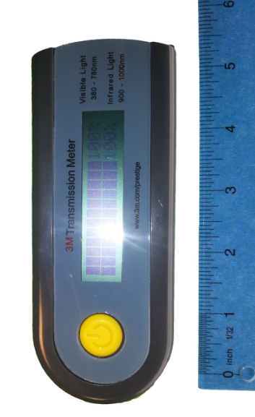
Figure 4: Commercial TM-3M Transmission Meter.

It is able to simultaneously measure and display IR rejection value and visible light transmission value. This meter is self-contained light sources and self-calibration. No manual adjustment is needed. The users only need plug the power supply, turn on the switch and put the solar film in the opening. The resulting performance data reported by manufacturer shows that it can be used in the region between 380 nm and 780 nm with ±2% accuracy (colourless and transparent material). This step is to validate the reading of VLT of each thin film. Then, the known-VLT thin films were measured by using an optical method. Spectrometer will detect the intensity of the light that passed through the thin film and results will be displayed by using SpectraSuite software.

Thin films are laminated on a clear glass plate as shown in Figure 5 so that it can easily stand vertically. This is to ensure that the beam that pass through is perpendicular to the surface of the thin film to reduce any light scattering.

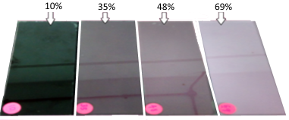
Figure 5: Thin films on glass plate holder.

Results and Analysis
In initial experiment, the VLT-of known thin films were measured using a commercial device TM-3M Transmission meter. The percentage of VLT-thin films that had been recorded by commercial transmission meter was 10%, 35%, 48% and 69% as shown in Table 1. The measured value of 10% and 35% VLT thin film show a perfect reading. However the value of 50% and 70% are slightly lower than the VLT percentage labelled by the manufacturer. This is due to the thin films are laminated on the glass plate that can absorb some of the light transmission.

Table 1: Measured VLT of a few series of thin films.

Labelled VLT (%) by manufacturer | Measured VLT (%)  by TM-3M meter
10 | 10
35 | 35
50 | 48
70 | 69

This value is also aligned with the TM-3M meter specification whereby it has ±2% accuracy. Therefore these measured values are acceptable. Then the experiment was followed by a measurement using an optical method. In this measurement, SpectraSuite software is used to record the intensity and the integration time of the measurement is set to 0.1 s. Based on the spectrum displayed on SpectraSuite, the best peak that light transmits is in between 536-539 nm. Thin film with high percentage of VLT will allowed more light to pass through it. The intensity counts recorded is higher and the result is shown in Table 2 below.

Table 2: Transmitted intensity of a few series of thin films.

VLT of thin film (%) | Intensity (Counts)
10 | 11154
35 | 15767
48 | 29918
69 | 35575

In order to view the difference VLT percentage have difference counts clearly, a graph of intensity versus wavelength is plotted as shown in Figure 6.

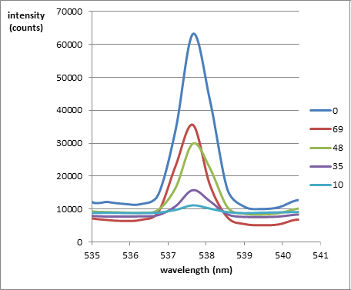
Figure 6: Intensity of light vs. wavelength of VLT thin film

As can be seen, the percentage of VLT-thin film increase, the light intensity is also increase at the wavelength between 536-539 nm. These measured values can be used as a reference for future development of an optical sensor system to measure VLT. However some improvement need to be carried out since the increment of the intensity counts in not align with increment of VLT percentage.

Conclusion and Future Works

Based on the result, the developed measurement system is capable to measure intensity of different set of thin film visibilities at the region in between 536-539 nm. The measurement system also shows fast response time which is 0.1 s. The purpose of this experiment is to develop a VLT measurement system in the future by using an optical method is achieved. It has a potential to be used to measure the haze index as an alternative method. For future works, this setup will be used to measure the real smoke in a chamber. This is to verify that the measurement system is capable of measuring haze in the future. This system is expected to be an alternative method to measure haze with a fast response time. It is also expected that the real time monitoring can be carried out using a LabVIEW programming.
Acknowledgement

The authors would like to thank Hadi Manap for his advice and guidance throughout this research. The author’s sincere appreciations are also extended to staff of Electrical Department, Faculty of Engineering Technology who contribute their time, energy and idea to complete this research and their cooperation are most delighted. Also the authors would like to acknowledge the support of the AEC, University of Malaysia, Pahang (UMP) in providing a research fund RDU1703216 for this research. Not to forget, research collaborators from Universiti Teknologi Malaysia (UTM).

References
BBC news, “What causes South East Asia's haze?”, Oct 2015, from http://www.bbc.com/news/world-asia-34265922

Department of Environment (DOE), “Air Pollutant Index (API)”, Official Portal of Ministry of Natural Resources & Environment Malaysia Last update: 4 Oct 2017, from https://www.doe.gov.my/portalv1/en/info-umum/english-air-pollutant-index-api/100.

Mingsheng Li, Lin Jia, Fengying Zhang, Maogui Hu, Yu Shi, Xi Chen, "Characteristics of haze weather in Chongqing, China and its determinants analysis based on automatic monitoring stations", Atmospheric Pollution Research, Vol. 7, Issue 4, July 2016, pp. 638-646.

Sam-Quarcoo Dotse, Lalit Dagar, Mohammad Iskandar Petra, Liyanage C. De Silva, " Influence of Southeast Asian Haze episodes on high PM10 concentrations across Brunei Darussalam", Environmental Pollution, Volume 219, December 2016, pp. 337-352.

De Lin Show, Su-Chin Chang, " Atmospheric impacts of Indonesian fire emissions: Assessing Remote Sensing Data and Air Quality During 2013 Malaysian Haze", Procedia Environmental Sciences, Volume 36, 2016, pp. 176-179.

Xie, X.S., Tao, S.C., Zhou, X.J., “Measuring visibility using digital photography”. Chinese Science Bulletin. 44, 1999, pp. 1130-1134.

O’Loingsigh, T., McTainsh, G.H., Tapper, N.J., Shinkfield, P., “Lost in code: acritical analysis of using meteorological data for wind erosion monitoring”, Aeolian Res. 2, 2010, pp. 49-57.

H Manap, G Dooly, S O'Keeffe, E Lewis, "Ammonia detection in the UV region using an optical fiber sensor", Sensors, 2009 IEEE, pp. 140-145.

S O'Keeffe, H Manap, G Dooly, E Lewis, "Real-time monitoring of agricultural ammonia emissions based on optical fibre sensing technology”, Sensors, 2010 IEEE, Pages 1140-1143.

Mazuina Mohamad, Hadi Manap, "An Overview of Optical Fibre Sensors for Medical Applications", International Journal of Engineering Technology and Sciences IJETS, Vol. 1, No. 1, June 2014.

H. Manap, G Dooly, S O'Keeffe, E Lewis, "Ammonia detection in the UV region using an optical fiber sensor", Sensors, 2009 IEEE, pp.140-145.

H. Xia, W Liu, Y Zhang, R Kan, M Wang, "An approach of open-path gas sensor based on tunable diode laser absorption spectroscopy", Chinese Optics Letters Vol. 6, Issue 6, 2008, pp. 437-440.

