|  |  |  |  |  |  |
| --- | --- | --- | --- | --- | --- |
|  | | Journal of Advanced Research in Fluid Mechanics and Thermal Sciences | |  | |
| Journal homepage: www.akademiabaru.com/arfmts.html  ISSN: 2289-7879 | |
|  | | | | | |
| Review on Development of Oxygen/Nitrogen Separations Technologies | | | | | Open  Access |
|  | | | | | |
| Fatin Nurwahdah Ahmad1, Norazlianie Sazali1,2,[1]*, and Mohd Hafiz Dzarfan Othman3 | | | | | |
| 1 | Faculty of Mechanical Engineering, Universiti Malaysia Pahang, 26600 Pekan, Pahang, Malaysia | | | | |
| 2 | Centre of Excellence for Advanced Research in Fluid Flow (CARIFF), Universiti Malaysia Pahang, Lebuhraya Tun Razak, 26300 Gambang, Kuantan, Pahang, Malaysia | | | | |
| 3 | Advanced Membrane Technology Research Centre (AMTEC), School of Chemical and Energy, Faculty of Engineering, Universiti Teknologi Malaysia, 81310 Skudai, Johor Darul Takzim, Malaysia | | | | |
|  |  | | | | |
|  | | | | | |
| **ARTICLE INFO** | | | **ABSTRACT** | | |
| ***Article history:***  Received 22 August 2019  Received in revised form 14 September 2019  Accepted 29 October 2019  Available online 30 November 2019 | | | Various industrial sectors such as chemical, medical and upgraded combustion operations are demanding for the oxygen-enriched gas. Pressure swing adsorption and cryogenic distillation are the well-known approaches used for oxygen-nitrogen separation that capable to produce a large daily volume of oxygen with high purity. Nevertheless, these technologies are not preferable due to their high energy consumption. Therefore, membrane technology is introduced as an alternative method to separate gas since it has advantages compared to other approaches in the context of energy consumption. Since this alternative technology is cost-effective, abundant of researches have been carried out to develop membranes with surpassing oxygen-nitrogen separation performance that meets the specifications for industrial applications. The objectives of this paper are to analyze the traditional technologies and membrane technology for oxygen-nitrogen separation, the latest procedures and precursors materials used in fabricating the membranes, including the recent study of membrane performance for oxygen-nitrogen separation. | | |
| ***Keywords:*** | | |  | | |
| Membrane; gas separation; permeability; selectivity and oxygen-nitrogen separation | | | **Copyright © 2019 PENERBIT AKADEMIA BARU - All rights reserved** | | |

**1.0 INTRODUCTION**

Adolf Ficks stated that the principle of gas molecules transportation across a membrane is from the high concentration region to the lower concentration region which mathematically justified by diffusion equation of Fick’s laws in the year 1855 [1]. In that era, leather and cotton were used as the membrane materials for separation. An asymmetric cellulose acetate membrane is introduced a century later by employing the phase inversion method in the fabrication process [2]. The membrane is used for reverse osmosis, showing that membrane technology has been widely implemented into the water separation process. Currently, membrane technology has become a relevant alternative for industrial scale gas production only about thirty years ago [3-5]. Various applications require oxygen-enriched air, such as in enhancing the combustion process for furnace also in improving the treatment process of sewerage in plants [6]. Oxygen-enriched air is used for the engine of coal-fired and natural gas combustion process with the objectives of reducing fuel consumption and enhancing the quality of indoor oxygen gas that can be achieved by the induction of oxygen gas into the combustion process [7, 8].

Enrichment of oxygen air can be produced by two conventional technologies which are pressure swing adsorption (PSA) and cryogenic distillation. Generally, cryogenic distillation is employed for large-scale gas separation operation with high purity oxygen gas production capacity of more than 100 tonnes, while pressure swing adsorption is used for medium-scale gas separation operation with the capability to produce a volume of 20 up to 100 tonnes per day of high purity oxygen gas [9]. These technologies have been introduced in the industry approximately 70 years ago, however, there are disadvantages in terms of energy consumption and cost-effectiveness in which higher capital cost and energy consumption are required compared to membrane technology. Specifically, cryogenic distillation technique involves the usage of compressors and turbines causing increase in capital cost also, the cooling process of gas to a temperature below boiling point needs a very high energy. These drawbacks become the limitation of its application in gas separation plants (large scale). While for pressure swing adsorption (PSA) technique, the limitations of its application are deteriorating efficiency and the need of high energy consumption. Membrane technology is a small to medium scale production technique with the capability to yield oxygen gas with a volume in the scale between 10 tonnes up to 25 tonnes per day of 25% to 40% oxygen purity [10]. The chronology of the advancement of membranes have been discussed including the gas separation process for various binary pairs gases, and this review paper will be continued by discussing on the three technologies used for oxygen-nitrogen separation, the preparation procedures and type of precursors used, also emphasizing on the current development of oxygen-nitrogen separation utilizing membrane technology to fulfil industrial demands.

1. **OXYGEN/NITROGEN SEPARATION TECHNOLOGIES**

At present, the application of membrane technology is not widely used for gas separation yet, especially for the oxygen-nitrogen separation process. The technologies that currently dominating in the oxygen-nitrogen gas separation process are cryogenic distillation and pressure swing adsorption [11-13] which will be discussed in the next sub-topics.

* 1. **Membrane Technology**

Membrane technology becomes preferable compared to the conventional technologies which are cryogenic distillation and pressure swing adsorption in the industry of gas separation because it requires only low capital cost and low energy consumption [14]. For membrane gas separation, it starts with invading air from the atmosphere progressing the membrane module then gas will be separated according to their difference in solubility and diffusivity. Since oxygen has high diffusivity, it will be collected at the upstream of the module and nitrogen is collected at the downstream. Currently, the membrane separation technique able to yield oxygen with a purity between 25% to 40% and its daily production volume is in the range of 10 up to 25 tonnes of oxygen [15]. Fabrication of membranes depends on several factors such as type of membrane. One of the methods to fabricate membrane is phase inversion method.

The phase inversion method or called as a phase separation method is a transformation process of polymer dope solution into a solid phase by the solvent-nonsolvent exchange. Flat sheet and hollow fiber membranes could be fabricated using this method, however, it depends on the fabrication equipment setup. Firstly, the polymer dope solution will be soaked in a nonsolvent coagulation bath allowing the solvent-nonsolvent exchange to take place. Here, the demixing process occurs [16,17]. Next, the phase separation occurs through the evaporation of the solvent in the coagulation bath, allowing the polymer to solidify. Based on the literature review, the phase inversion technique has been implemented and involved in several dense-structured membrane productions for the gas separation process [18, 19]. The methods in producing the nanofiber membrane mat and hollow fiber membrane are different, Figure 1 and Figure 2 respectively [20, 21].

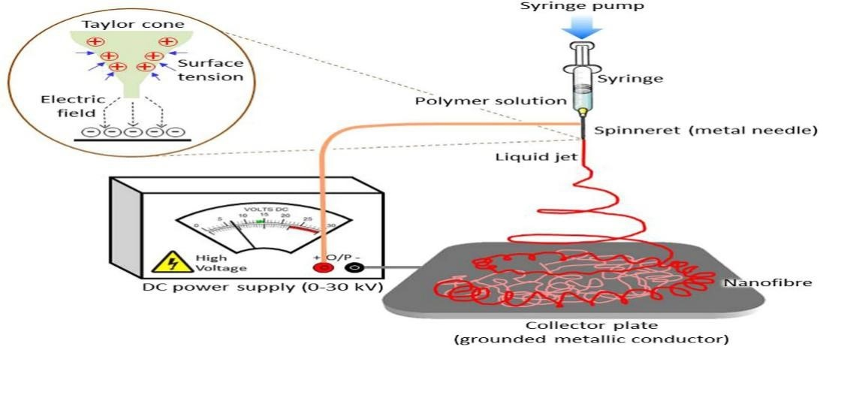

**Figure 1:** The setup of electrospinning method to produce nanofiber membrane mat [22]

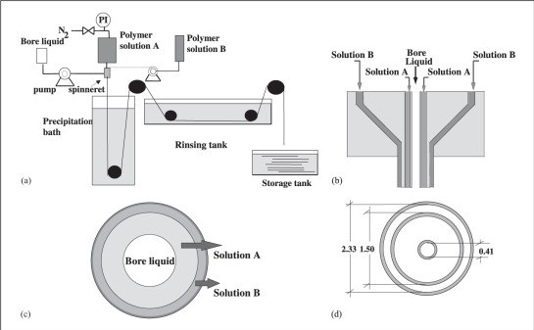

**Figure 2:** The setup of hollow fiber spinning system [23]

**2.2 Pressure Swing Adsorption (PSA)**

Pressure swing adsorption (PSA) is the common approach used for a commercial practice where adsorption of gas will take place in a high-pressure gas column by the adsorbent, for example, zeolite and silica. The feed gas from the atmosphere is drawn then compressed into high-pressure gas [24]. The high-pressure gas will be transported to a column containing adsorbent materials that are chosen depending on the type of gas desired. In the case of a pressurized environment, the low sorbing gas in the column will be withdrawn first then followed by higher sorbing gas through pressurization and depressurization to atmospheric pressure for a fixed period [25]. The procedure is similar for the adsorption process that occurs in a vacuum environment and known as vacuum swing adsorption (VSA) [26]. Pressure swing adsorption has redundancy in its system where two or more adsorbent columns are used to prevent the production of gas being interrupted during the process of pressurization and depressurization due to system down, Figure 3. Pressure swing adsorption is usually used for medium scale production with the volume in the range of 20 up to 100 tonnes of oxygen with 90% oxygen purity [27]. A gas production company which is Praxair has combined the pressure swing adsorption and vacuum swing adsorption into a process named vacuum pressure swing adsorption (VPSA) resulting in a higher daily oxygen gas production and higher purity which is 218 tonnes and 95% respectively [28].

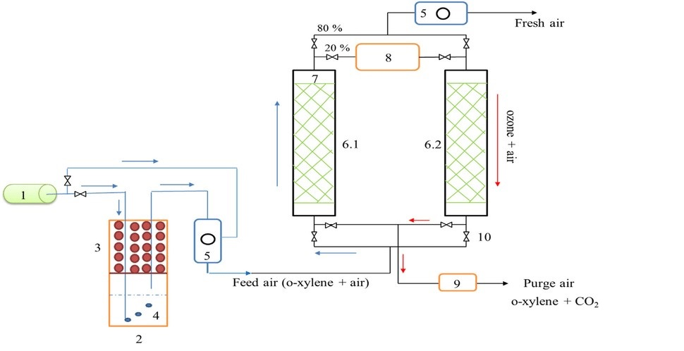

**Figure 3:** The Schematic Diagram of PSA Process [29]

**2.3 Cryogenic Distillation**

Cryogenic distillation is a process which has a similar operating system as the conventional air distillation which can also be called as a cryogenic liquefaction process, Figure 4. This process starts with allowing the ambient air (feed gas) to be invaded and compressed by a multistage air compressor which will later be refined by air filter to eliminate the impurities [11]. This process is continued by reducing the compressed air temperature with the purposes of removing carbon dioxide, also tracing hydrocarbon and water vapor before the air is liquefied and transported into the distillation column. Here in the distillation column, the extraction of nitrogen will occur at the top of the column since nitrogen has a lower boiling point. Oxygen gas with a higher boiling point will be withdrawn from the bottom of the column. The remaining feed gas in the distillation column will undergo further purification process by repeating the procedures to obtain the desired oxygen concentration [8]. Cryogenic distillation is capable to produce high purity oxygen which is more than 99% in a large volume of approximately more than 100 tonnes per day [12]. As of now, the gas producer companies, for example, Air Products and Linde yield oxygen and nitrogen for the industrial purpose from more than 5000 oxygen production plants globally by implementing cryogenic distillation technology [28].

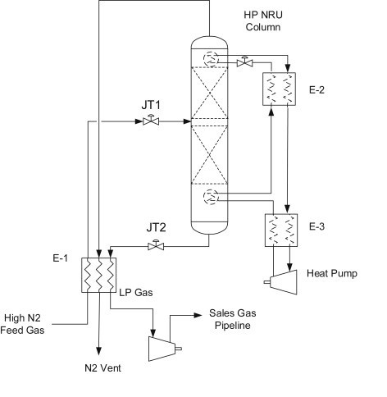

**Figure 4:** The schematic diagram of cryogenic distillation technology [30]

**2.4 Comparison of Gas Separation Technologies**

All of the gas separation technologies which are cryogenic distillation, pressure swing adsorption (PSA) and membrane have their unique process systems (explained earlier), advantages and disadvantages. For pressure swing adsorption, the solvent used (depends on the condition) can be recycled which will reduce cost. This technique is capable to produce high purity gas with a purity percentage of 95. The equipment required in this method is only suitable vessels that can withstand small pressure changes. The continuous monitoring and automation can be minimized as its operation is independent of humans. Suitable instrumentation and surveillance reduce costs. Although its system may reduce cost, the total cost which consists of other operating and maintenance (O&M) costs is around $40 to $70 per tonne gas separated which can be considered expensive [45]. The system is incapable to control large gas concentration. For cryogenic distillation, it has a major advantage because its product is in liquid form with a very high gas purity of around 99.95% which is ready to be transported. This method requires very high energy and cost-ineffective to ensure the system is cooled. Its cost is approximately $32.7 per tonne of gas separated [46]. Both technologies can be improved, optimized and their limitations can be reduced. The advantage of membrane technology is its simplicity compared to pressure swing adsorption which needs swinging pressure equipment and cryogenic distillation that require equipment to withstand extreme operating temperature. The membrane separation process only needs membranes and fans. The compression of gas in membrane separation is smaller than in pressure swing adsorption. Generally, the product from this method has a low purity percentage. Most of the membranes are not strong enough towards high temperature and pressure changes. Furthermore, it has been reported that an automated membrane gas adsorption (MGA) control system could improve the membrane performances [47].

**3. CONFIGURATION OF MEMBRANE MODULE**

Generally, membrane configurations can be categorized into two, which are supported (flat sheet and tube) and unsupported (flat sheet, capillary, and hollow fiber membrane), Figure 5 [31]. The membrane module is designed with the objectives to obtain membrane with high surface to volume ratio, high efficiency of separation performance and low-pressure drop. Flat sheet membrane configuration with low packing density and poor gas flow pattern is not compatible with gas separation that involves the passing through of high-pressure driving force [32]. Hollow fiber and spiral wound membrane configurations are more preferable in the gas separation industry. Both hollow fiber and spiral wound membrane modules are composed of a flat membrane sheet. The hollow fiber membrane is formed by packing the flat sheet membrane while the spiral wound membrane module is formed by rolling the flat sheet membrane creating envelope layers which will be separated by a spacer. Other than capable to withstand high pressure, the surface to volume ratio of these membrane configurations can be optimized.

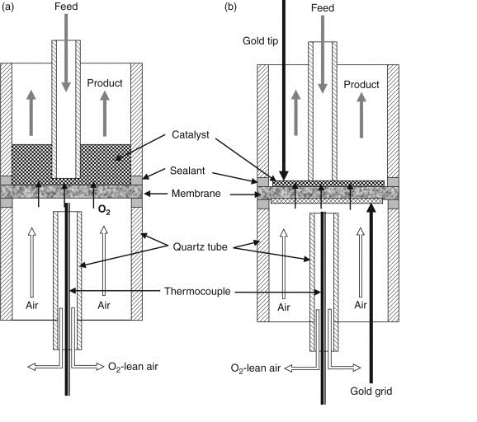

(a)

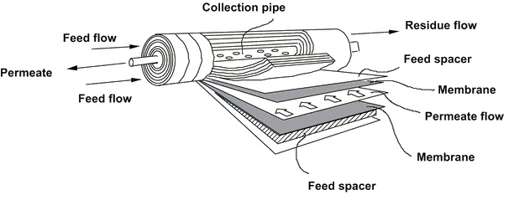

(b)

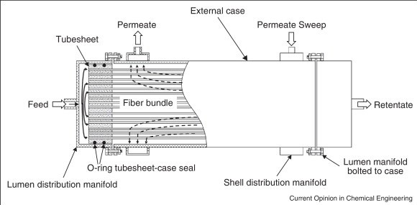

(c)

**Figure 5:** Membrane configurations: (a) flat sheet membrane [33], (b) Spiral wound [34], and (c) hollow fiber [35]

**4. PERFORMANCE OF MEMBRANES**

The factors contributing to the oxygen-nitrogen separation performance are the permeability and selectivity. The properties a membrane should possess to be commercialized are high gas selectivity and permeability, also chemically and mechanically stable for a long operating period. In the context of permeability and selectivity for membrane separation performance, they are determined by their thickness and membrane morphology. The basic principle emphasizing on the membrane morphology for gas separation, the membrane should have spongy structure and low membrane thickness, Figure 6. Other factors affecting the selectivity of a membrane is the precursor materials used during fabrication. Based on researches that have been conducted, polyimide, poly (2,6-dimethyl-1,4-phenylene oxide) and polysulfone: PI, PPO, and PSU show the higher good selectivity among other polymeric materials [36-38]. Robeson discovered that the potential membrane to be commercialized is depending on the relationship between the permeability and selectivity of the membrane. The Robeson upper bound for three years or also known as the gas separation trade-off limit, Figure 7. Robeson has put together various findings of membrane gas separation in binary pair such as oxygen-nitrogen, oxygen-methane, oxygen-carbon dioxide, etc. into a correlation in the year 1980 then revised in 1991 and 2008 corresponding to the development in selectivity and permeability of membrane [39, 40]. In the gas separation process, the Robeson upper bound has always been used as the benchmark for the membrane performance. It is expected that the Robeson’s upper bound limit will be revised soon as there are numerous research works, also findings on polymeric materials and technologies [41, 42]. Polyimide, poly (2,6-dimethyl-1,4-phenylene oxide) and polysulfone are the polymeric materials that demonstrate performance above the Robeson’s upper bound in 2008. It is reported, the polyimide carbon membrane has the permeability of 200 up to 800 Barrer and selectivity of 7.5 to 15 for oxygen-nitrogen separation. A lot of researches and improvements need to be done for membrane technology to compete with other oxygen-nitrogen separation technologies [44]. The growing development of the membrane technology shows that there is a possibility for membrane technology to be commercialized in the oxygen-nitrogen separation process.

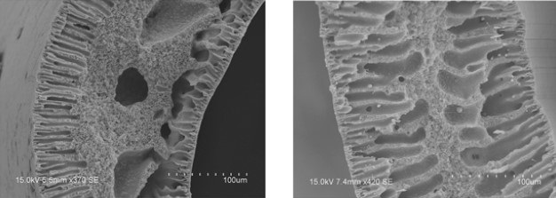

(a)



(b)

**Figure 6:** (a) Spongy-like structure membrane and, (b) finger-like structure membrane [43]

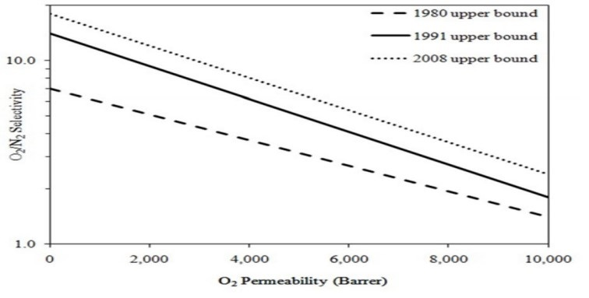

**Figure 7:** Robeson upper bound during 1980, 1991 and 2008

**5. CONCLUSIONS**

Nowadays, membrane technology is becoming one of the important technologies for gas separation which has been improved significantly since being introduced in early 1960. The evolution and improvements of membrane throughout the six decades cover on methods in fabricating membrane which shows the potential to be a technically and economically membrane for gas separation. The recent research on various polymeric membrane materials such as polyimide, poly (2,6-dimethyl-1,4-phenylene oxide) and polysulfone have been conducted and these researches of polymeric membrane increase the potential and possibility of yielding mixed matrix, selective layer and crossed-linked membranes that relatively important in enhancing the selectivity and permeability for the oxygen-nitrogen separation process. The membrane technology has a considerably high potential compared to the current conventional separation technologies such as pressure swing adsorption and cryogenic distillation to produce oxygen to fulfill the demands from the industry.

**Acknowledgement**

Special thanks to the Ministry of Higher Education and Universiti Malaysia Pahang for providing the financial support under the Fundamental Research Grant Scheme RACER (Project Number: RDU192615) throughout this research.

**REFERENCES**

[1] S. Fakirov. "Condensation Polymers: Their Chemical Peculiarities Offer Great Opportunities." Progress in Polymer Science. (2018).

[2] X. He, M.B. Hägg. "Hollow fiber carbon membranes: From material to application." Chemical Engineering Journal (2013): 440-8, 215-216.

[3] N.H. Ismail, W.N.W Salleh, N. Sazali, A.F. Ismail, N. Yusof, F. Aziz. "Disk supported carbon membrane via spray coating method: Effect of carbonization temperature and atmosphere." Separation and Purification Technology (2018): 195, 295-304.

[4] N. Sazali, W. Norharyati, N. Arsat, Z. Harun, K. Kadirgama. "P84 Co-Polyimide-based Tubular Carbon Membrane: Effect of Pyrolysis Temperature." (2018) 23, 17-24.

[5] N. Sazali, Z. Harun, W. Norharyati, N.A.H.M. Nordin, N. Yusof, A. Ismail. "Gas permeation properties of the Matrimid based carbon tubular membrane: The effect of carbonization temperature." International Journal of Conceptions on Mechanical and Civil Engineering (2015): 2357,760.

[6] V.A. Sadykov, A.V. Krasnov, Y.E. Fedorova, A.I. Lukashevich, Y.N. Bespalko, N.F Eremeev. "Novel nanocomposite materials for oxygen and hydrogen separation membranes." International Journal of Hydrogen Energy, (2018).

[7] C.Z. Liang, W.F. Yong, T-S. Chung. "High-performance composite hollow fiber membrane for flue gas and air separations." Journal of Membrane Science, (2017): 541(Supplement C),367-77

[8] N. Sazali, W. Norharyati, A. Ismail, K. Kadirgama, M. Samykano, G. Najafi. "PI/NCC-Based Tubular Carbon Membrane: Influence of Aging Times Towards Oxygen Separation Performance." (2018): 187, 96.

[9] R. Krishna. "Methodologies for screening and selection of crystalline microporous materials in mixture separations." Separation and Purification Technology, (2018): 194, 281-300.

[10] C. Castel, L. Wang, J.P. Corriou, E. Favre. "Steady vs unsteady membrane gas separation processes." Chemical Engineering Science, (2018): 183, 136-47.

[11] J. Sunarso, S.S. Hashim, Y.S. Lin, S.M. Liu. "Membranes for helium recovery: An overview on the context, materials and future directions." Separation and Purification Technology, (2017): 176, 335-83.

[12] D. Popov, K. Fikiin, B. Stankov, G. Alvarez, M. Youbi-Idrissi, A. Damas. "Cryogenic heat exchangers for process cooling and renewable energy storage: A review." Applied Thermal Engineering, (2019): 153, 275-90.

[13] S. Sonawane, K. Patankar, A. Fogla, B. Puranik, U. Bhandarkar, S. Sunil Kumar. "An experimental investigation of thermo-physical properties and heat transfer performance of Al2O3-Aviation Turbine Fuel nanofluids". Applied Thermal Engineering, (2011): 31(14), 2841-9.

[14] M. Rezakazemi, M. Sadrzadeh, T. Matsuura. "Thermally stable polymers for advanced high-performance gas separation membranes." Progress in Energy and Combustion Science, (2018): 66, 1-41.

[15] B. Belaissaoui, Y.L. Moullec, H. Hagi, E. Favre. "Energy Efficiency of Oxygen Enriched Air Production Technologies: Cryogeny vs Membranes." Energy Procedia, (2014): 63, 497-503.

[16] R.J. Lee, Z.A. Jawad, A.L. Ahmad, J.Q. Ngo, H.B. Chua. "Improvement of CO2 /N2 separation performance by polymer matrix cellulose acetate butyrate." IOP Conference Series: Materials Science and Engineering, (2017): 206(1), 012072.

[17] W. Choi, P.G. Ingole, J-S. Park, D-W. Lee, J-H. Kim, H-K. Lee. "H2/CO mixture gas separation using composite hollow fiber membranes prepared by interfacial polymerization method." Chemical Engineering Research and Design, (2015): 102, 297-306.

[18] N. Spahis, M. Dellali, H. Mahmoudi. "Synthesis and Characterization of Polymeric/Activated Carbon Membranes." Procedia Engineering, (2012): 33, 47-51.

[19] J-F. Blanco, J. Sublet, Q.T. Nguyen, P. Schaetzel. "Formation and morphology studies of different polysulfones-based membranes made by wet phase inversion process." Journal of Membrane Science, (2006): 283(1), 27-37.

[20] N. Kitayama, H. Keskkula, D.R. Paul. "Reactive compatibilization of nylon 6/styrene–acrylonitrile copolymer blends. Part 1: Phase inversion behavior." Polymer, (2000): 41(22), 8041-52.

[21] E.J. Moon, J.W. Kim, C.K. Kim. "Fabrication of membranes for the liquid separation: Part 2: Microfiltration membranes prepared from immiscible blends containing polysulfone and poly(1-vinylpyrrolidone-co-acrylonitrile) copolymers." Journal of Membrane Science, (2006): 274(1), 244-51.

[22] K. Ghosal, A. Chandra, S. Roy, C. Agatemor. "Electrospinning over Solvent Casting: Tuning of Mechanical Properties of Membranes." Scientific Reports, (2018:, 8(1), 5058.

[23] K.C. Khulbe, T. Matsuura. "Recent progress in polymeric hollow-fibre membrane preparation and applications." Membrane Technology, (2016): 2016(7), 7-13.

[24] A.M. Abdalla, S. Hossain, O.B. Nisfindy, A.T. Azad, M. Dawood, A.K. Azad. "Hydrogen production, storage, transportation and key challenges with applications: A review." Energy Conversion and Management, (2018): 165, 602-27.

[25] G.Q. Lu, J.C. Diniz da Costa, M. Duke, S. Giessler, R. Socolow, R.H. Williams. "Inorganic membranes for hydrogen production and purification: A critical review and perspective." Journal of Colloid and Interface Science, (2007): 314(2), 589-603.

[26] P. Samaddar, Y.S. Ok, K-H. Kim, E.E. Kwon, D.C.W. Tsang. "Synthesis of nanomaterials from various wastes and their new age applications." Journal of Cleaner Production, (2018): 197, 1190-209.

[27] S. Sridhar, B. Smitha, A. Shaik. "Pervaporation‐Based Separation of Methanol/MTBE Mixtures—A Review." Separation & Purification Reviews, (2005): 34(1), 1-33.

[28] T. Hu, H. Zhou, H. Peng, H. Jiang. "Nitrogen Production by Efficiently Removing Oxygen From Air Using a Perovskite Hollow-Fiber Membrane With Porous Catalytic Layer." Front Chem, (2018): 6, 329.

[29] G. Swetha, T. Gopi, S.C. Shekar, C. Ramakrishna, B. Saini, P.V.L Rao. "Combination of adsorption followed by ozone oxidation with pressure swing adsorption technology for the removal of VOCs from contaminated air streams." Chemical Engineering Research and Design, (2017): 117, 725-32.

[30] Z. Wang, L. Bao, X. Hao, Y. Ju. "Design and construction of a cryogenic distillation device for removal of krypton for liquid xenon dark matter detectors." Review of Scientific Instruments, (2014): 85(1), 015116.

[31] S. Saeidi, N.A.S Amin, M.R. Rahimpour. "Hydrogenation of CO2 to value-added products—A review and potential future developments." Journal of CO2 Utilization, (2014): 5, 66-81.

[32] S. Yuan, F. Shen, C.K. Chua, K. Zhou. "Polymeric composites for powder-based additive manufacturing: Materials and applications." Progress in Polymer Science, (2018).

[33] X. Tan, K. Li. "7 - Dense ceramic membranes for membrane reactors." In: Basile A, editor. Handbook of Membrane Reactors, 1: Woodhead Publishing, (2013): pp. 271-97.

[34] J. Balster. "Spiral Wound Membrane Module." In: Drioli E, Giorno L, editors. Encyclopedia

of Membranes, Berlin, Heidelberg: Springer Berlin Heidelberg, (2015): pp. 1-3.

[35] N.C. Mat, Y. Lou, G.G. Lipscomb. "Hollow fiber membrane modules." Current Opinion in Chemical Engineering. (2014): 4, 18-24.

[36] W.N.W. Salleh, A.F. Ismail. "Effects of carbonization heating rate on CO2 separation of derived carbon membranes." Separation and Purification Technology, (2012): 88(Supplement C), 174-83.

[37] J.B.S. Hamm, A. Ambrosi, J.G. Griebeler, N.R. Marcilio, I.C. Tessaro, L.D. Pollo. "Recent advances in the development of supported carbon membranes for gas separation." International Journal of Hydrogen Energy, (2017): 42(39), 24830-45.

[38] G. Wang, M. Liu, J. Du, L. Liu, Y. Yu, J. Sha. "Fabrication of hierarchical porous N-doping carbon membrane by using “confined nanospace deposition” method for supercapacitor." Applied Surface Science, (2018): 435(Supplement C), 424-31.

[39] L.M. Robeson. "The upper bound revisited." Journal of Membrane Science, (2008): 320(1), 390-400.

[40] L.M. Robeson. "Polymeric Membranes for Gas Separation." Reference Module in Materials Science and Materials Engineering: Elsevier, (2016).

[41] N.H. Ismail, W.N.W. Salleh, N. Sazali, A.F. Ismail. "Effect of intermediate layer on gas separation performance of disk supported carbon membrane." Separation Science and Technology, (2017): 52(13), 2137-49.

[42] N. Sazali, W. Norharyati, N.A.H.M. Nordin, M. Mohamed, A. Ismail, N. Yusof. "Influence of Carbonisation Temperature on Gas Permeation Properties of Matrimid-based Carbon Membrane." (2017): pp.145-50.

[43] W.N.W. Salleh, A.F. Ismail. "Effects of carbonization heating rate on CO2 separation of derived carbon membranes." Separation and Purification Technology, (2012): 88, 174-83.

[44] N. Sazali, W.N.W. Salleh, A.F. Ismail, N.A.H.M. Nordin, N.H. Ismail, M.A. Mohamed. "Incorporation of thermally labile additives in carbon membrane development for superior gas permeation performance." Journal of Natural Gas Science and Engineering, (2018): 49, 376-84.

[45] Chakma, A. and Tontiwachwuthikul, P. “CO2 Separation from Combustion Gas Streams by Chemical Reactive Solvents”. Combustion Canada: Online Library. (1990).

[46] Gottlicher, G. and Pruschek, R. "Comparison of CO2 removal systems for fossil‐fuel power plant processes." Energy Convers. Manage., (1997): 38(Suppl.): S173–S178.

[47] Abd Rahman, Sunarti & Ahmad, A. "Performances of Automated Control System for Membrane Gas Absorption: Optimization Study." (2019): 2289-7895.

1. * *Corresponding author.*

   *E-mail address: azlianie@ump.edu.my (Norazlianie Sazali)*