Effects of different processing parameters on the semisolid microstructure of Al6061 produced by a direct thermal method
M. F. M. Tajudin¹, *A. H. Ahmad¹, M. M. Rashidi²
¹Department of Mechanical Engineering. College of Engineering, Universiti Malaysia Pahang, 25150 Kuantan, Pahang, Malaysia
²Faculty of Mechanical and Automotive Engineering Technology, Universiti Malaysia Pahang, 26600 Pekan, Pahang, Malaysia

*Corresponding author: asnul@ump.edu.my
Abstract. The effect of different processing parameters consist of pouring temperature and holding time on the semisolid microstructure of Al6061 feedstock billet produced by direct thermal method has been investigated in the present paper. In this experimental works, molten aluminium alloy 6061 was poured into a thin cylindrical copper mould at a constant temperature of 660 °C and held at different holding times of 20 s, 40 s, and 60 s. After it reached the desired holding time, the copper mould was then quenched into room temperature water. The microstructure formation of feedstock billets was characterized after the feedstock billets were taken out from the mould. Results show that, due to the rapid cooling condition of the molten 6061 inside the copper mould, more globular microstructures were obtained. The sample produced with a pouring temperature of 660 °C and holding time of 20 s, globular microstructure were apparent. Simultaneously, the sample with a pouring temperature
of 660 °C and a holding time of 20 s produced smaller grain size than the sample with a pouring temperature of 660 °C and a holding time of 40 s and 60 s. Based on the results, the globular microstructures were superior at a shorter holding time, which allowed them to be quenched faster into room temperature water. The results from this experimental works suggest that the DTM feedstock billet globular microstructure formation merely depended on the heat convection of the molten alloy out from the copper mould. The faster heat convection out from the molten alloy which retarded the formation of dendritic microstructure thus transformed it into a globular microstructure for semisolid metal processing.
- Introduction
Flemings and Spencer first discovered SSM processing at the Massachusetts Institute of Technology (MIT) in 1971 [1– 6]. During the experiment with Sn-15%Pb alloy, the addition of shear during the solidification process significantly decreased the stress. Lowering the temperature resulted in a rapid increase in viscosity, but a higher shear rate decreased overall viscosity value and shorter time to reach steady-state conditions. The dendritic microstructure evolved into a globular microstructure generated by the shearing of the molten metal during cooling beyond the liquidus temperature. SSM processing occurs between solidus and liquidus temperature range, where the fluidity of molten metal can change significantly [7- 8]. The microstructure of the material will consist of solid near-globular grains surrounded by a liquid matrix and a broad solid-to-liquid transition region [5]. The spheroidal microstructure formation was influenced by controlling processing parameters such as pouring temperature and holding time.
SSM processing involves two main routes which are rheoforming and thixoforming [9]. In rheoforming routes, the SSM slurry was prepared from the liquid alloy and was followed by the shaping process. The Rheoforming process started with the molten alloy being cooled into the semisolid range before it was placed into a die without an intermediate solidification stage. The semisolid of non-dendritic solid particles were formed from a fully liquid state of regular alloy before it was cooled to achieve the solid fraction and then cast into components. The thixoforming process can produce high quality and near net-shaped products due to globular microstructure formation compared to the dendritic microstructure [9]. Thixoforming routes consist of two stages and involve an intermediate solidification process. The feedstock billets were solidified into the semisolid state by the quenching process. The feedstock billets were then reheated into the semisolid temperature before forming and cast into near net-shaped components. The thixoforming process offers improved mechanical properties, excellent surface finishing, and near net shape material.
Direct thermal method (DTM) is one of the SSM processing technique to produce globular microstructure. The DTM process was first discovered by D. Brabazon and coworkers in
1997[4, 10–12]. DTM is a method by which low superheated liquid alloys were poured into a copper mould to produce globular microstructure. The rapid heat absorption from the molten metal with the mould wall will provide multiple nucleations at the first contact. The low cool rates of the molten alloy caused the heat lost to the atmosphere. The equilibrium temperature was achieved below the alloy solidification range. The quenching process is a method of rapidly cooling the temperature of molten materials from high temperatures into low temperature [13]. Quenching process was performed to freeze globular microstructure formation.
Aluminium alloys can be divided into two groups, which are wrought aluminium alloys and cast aluminium alloys [14]. Aluminium alloys are widely used in automotive parts such as engine blocks for weight reduction, piston and cylinder head compared to the cast iron which was heavier than aluminium. Wrought aluminium alloys have higher mechanical properties as compared to cast aluminium alloys. The formation of magnesium silicide (Mg2Si) in the 6xxx series alloys makes them heat treatable. Wrought aluminium alloys 6061 are medium in strength, heat-treatable alloy, outstanding formability, weldability and better corrosion resistance [15-16].
The pouring temperature plays a vital role in SSM processing. Lowering the pouring temperature enhances the spheroidal microstructure formation and produce globular and in uniform form [8]. Lower pouring temperature above the liquidus temperature ends up in higher cooling rates as low superheat extraction of liquefied alloy with the copper mould [17].
The main aspect of holding time was to provide enough solid fraction before the quenching process. The solid fraction within the molten alloy influenced the globular microstructure formation during the solidification process. The higher holding time leads to higher grains size formation [17]. Based on the literature, the spheroidal microstructure formation was influenced by the pouring temperature and holding time. This experimental works aim to study the influence of the pouring temperature and holding time on the microstructure formation of DTM feedstock.
- Experimental procedure
Wrought aluminium alloy 6060 has been used in this experimental works. The wrought aluminium alloy 6061 was cut into 20 mm. It was ground using abrasive silicon paper with the grit specification of P120, P240, P320 and P600 to get flat and smooth surfaces before the chemical composition test. The chemical composition of aluminium 6061 was then compared with the ASM. The chemical composition of aluminium alloy 6061 is presented in Table 1.

Table 1: Chemical Composition of Aluminium 6061.

Composition | Al | Mg | Si | Cu | Fe | Cr | Zn | Mn
Wt ( %) | 97.7 | 0.92 | 0.72 | 0.27 | 0.19 | 0.07 | 0.01 | 0.01

Direct thermal method.
The copper mould was fabricated with 120 mm height and 27 mm diameter with a thickness of 1 mm. The base of the mould was designed with 50 mm times 50 mm copper plate. The copper mould needs to be jointed between the basement and the hollow copper. The joining part must also be checked to ensure there was no open space between the base and the copper hollow.
In this experiment, wrought alloy 6061 was melted inside the graphite crucible at a temperature of 900°C in the Carbolite box furnace. After the aluminium 6061 was utterly melt, the crucible was taken out, and the temperature of the molten alloy was measured. K type thermocouple that connected with data logger was used to measure the temperature of molten alloy. The molten alloys were then poured into the cylindrical copper mould after achieving the desired temperature. The pouring temperature was set at 660°C, while the holding time used was set to 20 s, 40 s, and 60 s. The room temperature quenching tank was used to freeze microstructure formation upon reaching the desired holding time. The schematic diagram of the DTM process is shown in Figure 1 as follows:

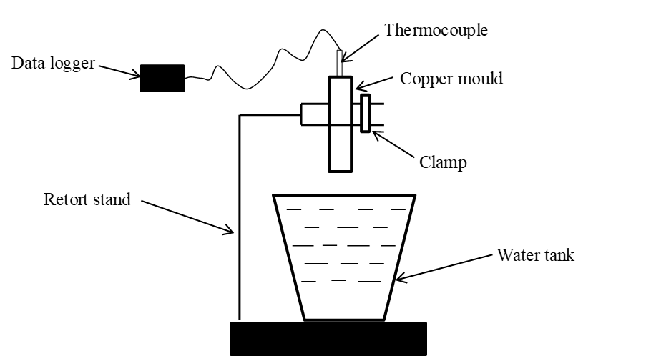

Figure 1: Schematic diagram of the DTM apparatus used in this experimental works.

Microstructure analysis sample preparation.
The semisolid feedstock billets were then cut into 5 mm at the bottom to remove the impurities. The sample was then sectioned into 20 mm length using a sectioning cut-off machine. The 20 mm sample was again cut into half using a precision diamond cutting machine with a cutting speed of 230 rpm. The sample was then mounted using a hot mounting machine with a pressure of 60 bar. The sample then ground manually using silicon carbide (SiC) abrasive paper with the grit specifications P120, P240, P320, P400, and P600 to reduce the cutting damage. The correct sequences and grit specification, grinding direction and load applied on the sample can affecting the sample flatness and smoothness of the sample surface. The grinding step was accomplished by decreasing the abrasive grit by sequent to obtain smooth and flat surface finishing. The sample was then ground using an automatic grinding machine with a rotation speed of 250 rpm and a grit level of P1200 and P2000.
The sample was then polished to remove the scratches from the grinding process. The sample was polished using diamond abrasives, ranging from 6-micron down to 1-micron diamond. The last step in microstructure sample preparation was the etching process. The main purpose of the etching process is to enhance the microstructural features such as primary grain size and phase features. The etchant was dabbing using cotton saturated with the Keller etchant reagent. The sample was held for 15 seconds before it was rinsed with the distilled water.
Image J software was used in determined the primary grain size, circularity and aspect ratio of the microstructure. The circularity of the globular microstructure indicates that the perfect round shape that exists within the primary grain. The circularity value that was closed to 1.0 meant that the grain had a perfect round or globular microstructure, while the value approaching 0 indicates that the grain has a stretched shape. The aspect ratio is a measure for a circular configuration, in which an elongated primary grain increases the aspect ratio value. Equation (1) and equation (2) represented the formula to calculate the aspect ratio and circularity of the primary grain, where p is the perimeter and A is the area of the grain:

$Circularity=\frac{4πA}{ p² }$ (1)

$Aspect Ratio=\frac{major axis}{minor axis}$ (2)

The microstructure images were observed using an Olympus microscope with Motic Image Plus 3.0 software. The images were observed under 5x and 20x magnification power to get the primary grain images. Three images were captured for each sample and the grain size area, circularity and aspect ratio were then calculated for three repeatability images for every sample. The microstructure was analyzed using Image J software. The scale has been fixed to 100 µm for each sample before analyzing the microstructure. The noise on the image must be adjusted to distinguish the exact primary grain with the scratches. The suitable selection of the microstructure is crucial to measure the primary grain circularity and aspect ratio.

Energy-dispersive X-ray Spectroscopy (EDXS) analysis.
The Energy-dispersive X-ray Spectroscopy (EDXS) analysis was carried out by Jeol JSM-7800F machine to measure the chemical composition of the DTM feedstock billets samples. The microstructure formation was observed while the EDXS detectors analyzed the composition data in the primary and secondary phases. The solid grain structure indicated that primary phases while liquid structure at the solid grain represented secondary phase.

- Results and discussion

Microstructure analysis.
Figure 2 shows the microstructure of aluminium 6061 produced by DTM captured using Motic Image Plus 3.0 software. The average for grain size, circularity and aspect ratio for each processing parameter is shown in Figure 3 as follows.

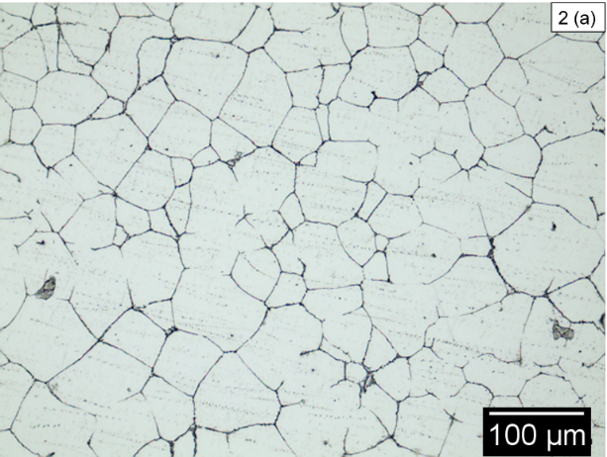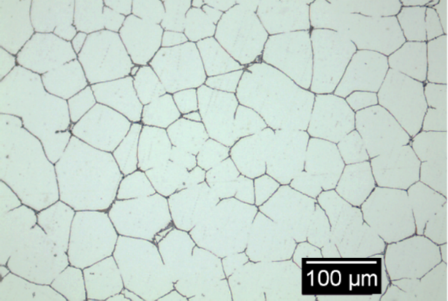
(a)
(b)

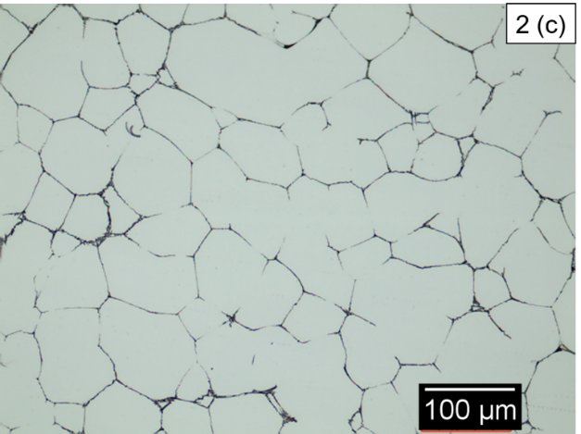
(c)
Figure 2: Microstructure formation for (a) sample 1 with the combination of 660 °C and 20 s;
(b) sample 2 with the combination of 660 °C and 40 s; and (c) sample 3 with the combination of 660 °C and 60 s.

(a)
(b)

(c)
Figure 3: Average grain size measurement with (a) grain size; (b) circularity; and (c) aspect ratio.
- The effect of pouring temperature the aluminium alloy 6061 microstructure produced by DTM.
There was a significant difference in microstructure between three samples quenched at various combinations of pouring temperature and holding time. Sample 1 with a pouring temperature of
660 ° C with 20 s of holding time produced small grain size particles at 2547.87 µm². According to the previous research, a lower pouring temperature could lead to the smaller primary and secondary phases in the grain and produce more globular microstructure [6, 18- 19]. The pouring temperature which has been used in this work was just slightly above the liquidus temperature that provides fewer superheated to be extracted from the copper, lead to higher cooling rates. The formation of globular microstructure was slow down when the low pouring temperature of molten metal was used before the solidification process [6, 20]. The rapid cooling process happened as the aluminium alloy was cooled from low superheat inside the copper mould. The heat extraction provided by the cylindrical copper mould allowed the superheated aluminium to be rapidly cooled into the semisolid state. The rapid cooling process improves multiple nucleation formation during the solidification process [17]. The combination with a pouring temperature of 660 °C and holding time of 20 s results in more globular microstructure at 0.75 compared to other samples. The globular microstructure increases the fluidity of the alloy during the shaping process. The smaller and more globular microstructure produces good formability due to the good movement of the particles and less collision between the particles within the microstructure [21- 22].

- The effect of holding time on the aluminium 6061 microstructure produced by DTM.
Holding time was primarily intended to ensure that enough solid fraction was achieved before the quenching process. The larger grain size of alloy microstructure caused by the longer holding time used before the solidification process [6]. The combination of a pouring temperature of 660 ° C and holding time of 60 s results in the largest grain formation at 3510.54 µm². The formation of globular microstructure and smaller grain size determined by the volume of fraction solid in molten aluminium alloy before it was quenched into the water tank [23]. The longer holding time promoted the grain to develop to each other within the alloy and produced a larger grain size. According to previous research, the fraction solid inside the alloy increase as it reached solidus temperature during the solidification process. The formation of nuclei become larger because of the rise in solid fraction during the solidification process [6]. The volume of fraction solid in the molten aluminium alloy 6061 was one of the essential processing parameters in SSM processing to determine the behaviour of the alloy [17].

Energy Dispersive X-ray Spectroscopy Analysis.
The EDXS analysis was conducted on two different regions which are primary and secondary phases area after the microstructure assessment. Three main elements were identified from the samples which were aluminium (Al), magnesium (Mg) and silicon (Si). The selected area of the primary and secondary phases used in EDXS analysis is presented in Figure 4 and Figure 5. Table 2 and Table 3 represent the chemical composition of DTM feedstock billets for the primary and secondary phase area.

Table 2: The primary phase chemical composition of DTM feedstock billets.
660°C 40 s | Elements | Al | Mg | Si
 | Spectrum (Wt %) | 89.63 - 95.97 | 0.61 – 0.79 | 0.67 – 1.46
660°C 60 s | Elements | Al | Mg | Si
 | Spectrum (Wt %) | 97.72 – 99.16 | 0.36-2.01 | 0.41 – 1.70

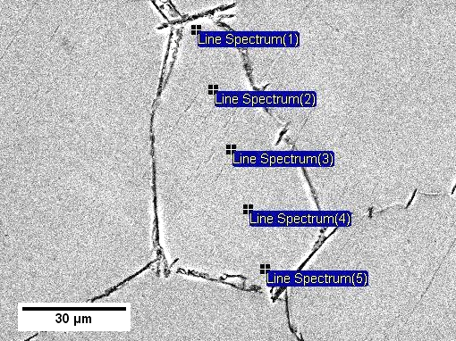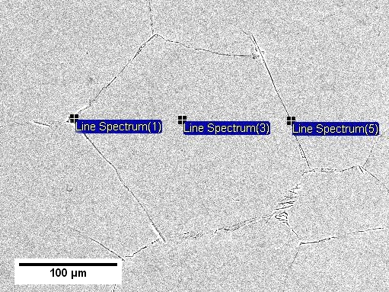
(a)
(b)

Figure 4: Selected primary Phases area for (a) combination pouring temperature of 660 °C and holding time of 40 s; and (b) combination pouring temperature of 660 °C and holding time of 60.
Table 3: The secondary phase chemical composition of DTM feedstock billets.
660°C 40 s | Elements | Al | Mg | Si
 | Spectrum (Wt %) | 54.37 – 82.89 | 0.85 – 2.94 | 3.32 – 22.15
660°C 60 s | Elements | Al | Mg | Si
 | Spectrum (Wt %) | 61.75 – 98.01 | 0.5 – 0.71 | 1.44 – 37.54

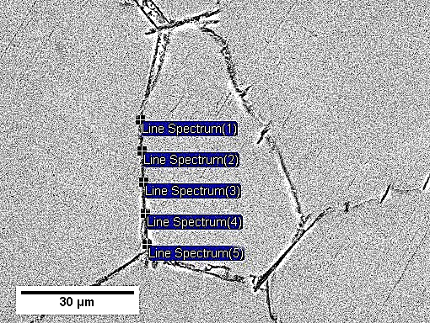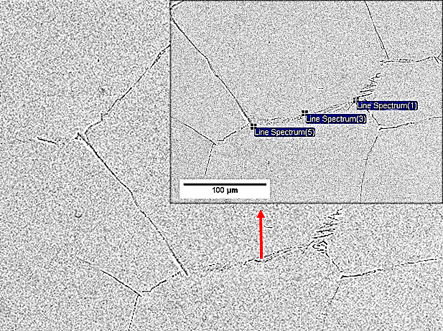
(a)
(b)

Figure 5: Selected secondary Phases area for (a) combination pouring temperature of 660 °C and holding time of 40 s; and (b) combination pouring temperature of 660 °C and holding time of 60.
The EDXS analysis showed that three main components were found, which were Aluminium (Al), Magnesium (Mg) and Silicon (Si) in both primary and secondary phases. The primary phases for the sample with combination pouring temperature of 660 °C and holding time of 60 s contain 97.72 % to 99.16 % of aluminium while combination pouring temperature of 660 °C and 40 s contain 89.63 to 95.97 % of aluminium. The secondary phases for the sample with a pouring temperature of 660 °C and holding time of 40 s contain only 54.37 to 82.89 % of aluminium. In comparison, the sample with a pouring temperature of 660 °C and a holding time of 20 s contains 61.75 to 98.01 % of aluminium.
The difference between the compositions along the grain boundary may cause by the precipitation sequence. The DTM feedstock billets which were quenched in room temperature water caused an incomplete precipitation sequence process. The high aluminium precipitates in the secondary phases were due to the presence of a homogenous α-Al solution [24]. The homogenous α-Al solution allowed the secondary phase to be dissolved and preventing the isolation of the alloy. The excess of the Si element in aluminium alloy 6061 was required to produce the stoichiometric of Mg2Si elements to improve the alloy properties due to metastable ß’’precipitation during the solidification process [25]. In the early precipitation sequence, the Si element was increasingly more than Mg elements, thus changing the agglomerate configuration [25- 26]. The minimum amount of Si elements precipitate in the alloy, the metastable ß’’ become less stable and reduced the properties of the alloy.

- Conclusion
In conclusion, these experimental works have successfully investigated the impact of specific pouring temperature and holding time on aluminium alloy 6061 feedstock billets produced by DTM. The specific pouring temperature and holding time used in this experimental works influence the microstructure formation during the solidification process. The combination of 660 °C and 20 s produces fine globular microstructure and smallest grain size compared to other parameters. This small grain size and near globular microstructure are good for forming operation. During the solidification process, the slow cooling rates facilitate the formation of nuclei which will develop smaller grain size. The globular microstructure formation purely depended on the heat convection of the molten alloy out from the copper mould. The faster heat convected out from the molten alloy, it will retard the formation of dendritic microstructure thus transformed it into globular microstructure for SSM processing. The lower pouring temperature enhances the formation of nucleation during the solidification process, thus produce more globular microstructure and smaller grain size.

Acknowledgement
The authors would like to appreciate the support from Universiti Malaysia Pahang for funding this experimental work with the grant numbers of RDU1603125 and RDU160311.

References
[1] Z. Chang, N. Su, Y. Wu, Q. Lan, L. Peng, and W. Ding, “Semisolid rheoforming of magnesium alloys : A review,” p. 108990, 2020.
[2] J. Jiang, Y. Zhang, Y. Wang, G. Xiao, Y. Liu, and L. Zeng, “Microstructure and mechanical properties of thixoforged complex box-type component of 2A12 aluminum alloy,” p. 108859, 2020..
[3] M. Rosso, I. Peter, and P. Torino, “New frontiers for thixoforming,” vol. 8, 2013.
[4] A. H. Ahmad, “Effect of Temporal Thermal Field on Quality of Semi-solid Metal Formed Components,” no. January, 2015.
[5] M. N. Abdulrazaq, “An Overview of Semi-Solid Metal Processing,” 2014.
[6] A. H. Ahmad, S. Naher, and D. Brabazon, “The Effect of Direct Thermal Method , Temperature and Time on Microstructure of a cast aluminium alloy,” 2014.
[7] B. Benjunior, A. H. Ahmad, and M. M. Rashidi, “Direct thermal method pouring temperature and holding time effect on aluminium alloy 6061 microstructure,”, 2020.
[8] N. A. Razak, A. H. Ahmad, and M. M. Rashidi, “Investigation of pouring temperature and holding time for semisolid metal feedstock production,”, 2017.
[9] M. Rosso, “Thixocasting and rheocasting technologies , improvements going on,” vol. 54, no. 1, pp. 110–119, 2012.
[10] D. J. Browne, M. J. Hussey, A. J. Carr, and D. Brabazon, “Direct thermal method: New process for development of globular alloy microstructure,” vol. 16, no. 4, pp. 418–426, 2003.
[11] A. J. Carr, D. J. Browne, M. J. Hussey, N. Lumsden, and M. Scanlan, “Modelling and experimental development of the direct thermal method of rheocasting,” vol. 20, no. 6, pp. 325–332, 2007.
[12] D. J. Browne, M. J. Hussey, and A. J. Carr, “Towards optimisation of the direct thermal method of rheocasting,” vol. 356, pp. 227–235, 2004.
[13] T. G. Liščić B, Tensi H., Canale L., Quenching Theory and Technology Second Edition. 2010.
[14] J. R. Davis, “Aluminum and Aluminum Alloys,” pp. 351–416, 2001.
[15] M. R. Rezaei, M. R. Toroghinejad, and F. Ashrafizadeh, “Effects of ARB and ageing processes on mechanical properties and microstructure of 6061 aluminum alloy,” pp. 1184–1190, 2011.
[16] S.-H. Lee, Y. Saito, T. Sakai, and H. Utsunomiya, “Microstructures and mechanical properties of 6061 aluminum alloy processed by accumulative roll-bonding,”, pp. 228–235, 2002.
[17] A. H. Ahmad, S. Naher, and D. Brabazon, “Direct Thermal Method of Aluminium 7075,” pp. 400–408, 2014.
[18] Z. L. Ning, H. Wang, and J. F. Sun, “Deformation behavior of semisolid a356 alloy prepared by low temperature pouring,” pp. 648–653, 2010.
[19] H. Wang, B. Li, J. Jie, and Z. Wei, “Influence of thermal rate treatment and low temperature pouring on microstructure and tensile properties of AlSi7Mg alloy,” pp. 2992–2996, 2011.
[20] A. H. Ahmad, S. Naher, and D. Brabazon, “Direct Thermal Method of Aluminium 7075,”, pp. 400–408, 2014.
[21] M. Flemings, “Behavior of Metal Alloys in the Semisolid State,” pp. 957–981, 1991.
[22] Z. Fan, “Semisolid metal processing,” pp. 49–85, Apr. 2002.
[23] M. Reisi and B. Niroumand, “Initial stages of solidification during semisolid processing of a transparent model material,” pp. 738–748, 2012.
[24] L. Kerkeni et al., “Mechanical Behavior of Precipitation Hardened Aluminum Alloys Welds,”p. 13, 2016.
[25] A. K. Gupta, D. J. Lloyd, and S. A. Court, “Precipitation hardening in Al – Mg – Si alloys with and without excess Si,” pp. 11–17, 2001.
[26] M. Cabibbo, S. Spigarelli, and E. Evangelista, “A TEM investigation on the effect of semisolid forming on precipitation processes in an Al-Mg-Si Alloy,” pp. 193–202, 2002.
[27] M. Murayama, K. Hono, M. Saga, and M. Kikuchi, “Atom probe studies on the early stages of precipitation in Al-Mg-Si alloys,” pp. 127–132, 1998.

