Experimental Study between TPU Flex and Silicon Materials Mechanical Properties as an Alternatives in Development of the CardioVASS Heart Model
Nur Afikah Khairi @ Rosli¹, Mohd Azrul Hisham Mohd Adib¹, Mok Chik Ming¹, Nurul Natasha Mohd Sukri¹, Idris Mat Sahat²and Nur Hazreen Mohd Hasni³
¹ Medical Engineering & Health Intervention Team (MedEHiT), Department of Mechanical Engineering, College of Engineering, Universiti Malaysia Pahang, 26300 Lebuhraya Tun Abdul Razak, Kuantan, Pahang, Malaysia.
² Human Engineering Group (HEG), Faculty of Mechanical & Automotive Engineering Technology, Universiti Malaysia Pahang, 26600 Pekan, Pahang, Malaysia.
³ Family Health Unit Pahang State Health Department, Jalan IM 4, 25582 Bandar Indera Mahkota, Kuantan, Pahang, Malaysia
azrul@ump.edu.my,nurafikahkhairi@gmail.com
Abstract. The development of a heart model for medical training purposes in the current market is still new. The mechanical properties and the selection of materials become the main elements in determining the type of materials used. This paper highlighted to study of the mechanical properties between TPU Flex shore 95 A and Room Temperature Vulcanizing (RTV) silicon to determine the suitability of the material for the development of the CardioVASS heart model. Both of the materials were assessed by utilizing the tensile, compression, and hardness test methods to prove the validity of the materials for the CardioVASS heart model. Results suggested that the TPU flex was two times superior to the RTV silicon materials in terms of strength and durability. However, the RTV silicon material was two times elastic rather than the TPU flex material. Both materials can be fabricated as CardioVASS heart model. In future, modification of the mechanical properties of the selected material was expected to form a better and functional heart model.
Keywords: TPU, Polyurethane, Silicon, Polymer, Three-Dimensional Printing, Hardness Test, CardioVASS Device, Medical, Healthcare, Heart Model
- Introduction
The emergence of revolving technology nowadays had paved ways for the polymers group material to be explored in many sectors, including in the medical sectors. The polyurethane thermoplastic (TPU) and silicon materials are the most common materials of the polymers group that had marked their contribution especially in the current market [1-8]. However, some factors needed to be reviewed before implemented these elastomeric materials for further use; the mechanical properties factors. As the materials were known as soft, biocompatible, and flexural materials, therefore there were some concerns regarding the strength, durability, and endurance of the substance to be applied in long-term usage. Thus, this research was conducted to evaluate the following materials that include the experimental tensile test, compression test, and hardness test.
Silicon is one of the feasible materials that had been a preference for medical and healthcare applications. This material has excellent material properties, accompanied by high flexibility, low biological activity, ease of fabrication, chemical and thermal stability, biocompatibility, and hydrophobicity [9-10]. Yadagari Poojari [9] in her research had suggested the encapsulation of the medical device implants by using silicone materials due to their excellent biocompatibility and mechanical properties. Mohamed Rahaman et. al., [11] had suggested the utilization of silicon nitride for ceramic implant materials, particularly in orthopedic surgery.
The TPU material commonly available as a rigid substance before extruded using the three-dimensional printer into the designated shapes. Most of the TPU usage revolved around the manufacturing and processing field that includes the footwear industry, cables, wires, and others [13]. Although the TPU material was not as popular as silicone in the medical fields, however, this material can be applied for similar purposes as silicone and have outstanding mechanical properties compared to silicone. For instance, the TPU has good tensile strength, tear, and abrasion resistance compared to the silicone material [14-15].
CardioVASS device or known as the cardiovascular simulator is a newly invented device that had been proposed to be utilized for the education and learning process. The history of this device started with the fabrication of an experimental heart-S apparatus [16-17] that was evaluated into few models and now was known as the CardioVASS device. The research of this device was divided into three research modes; the physiology of blood circulation in the human heart [18], the observation of the heart’s mechanism, and the comprehension of the pathophysiological state of the heart during the catheter insertion into the small arteries [19]. This research was also a continuation of the CardioVASS system study that focused on the fabrication of the heart model materials.
The objectives of this research are to study the mechanical properties of the TPU and silicon materials to determine the suitability material characteristics to be fabricated as a heart model for the CardioVASS device.
- Methodology
  - Fabrication of the Test Samples
The fabrication of the test samples started with designing the test samples using the Solidwork version 2016 software by referring to the ASTM D1621 for the compression test and ASTM D638 [20] specifications for the tensile test. The dog-bone specimens of the tensile test for TPU materials were directly printed using the Ender 3 Pro printer by setting up the printer to be compatible with the material setting in table 1 below. The figure 1a) and 1b) depicts the design and printing process during the experiment was carried out. Next, the compression test used a rectangular shape of specimens as shown in figure 2 below. The same method as the tensile test was applied while preparing for the compression test specimens. Since the silicon materials existed in the liquid form, the process of curing activities and mixture between silicon solution with the hardener solution were explained as in figure 3 below. Table 1 depicts the mechanical properties of the silicon materials.
Table 1. Mechanical Properties of the TPU Flexible Material [21]
Characteristics | Value
Durability | High
Strength | High
Flexibility | Very High
Chemical Resistance | Medium-High
Abrasion Resistance | High
Water Resistance | Medium
Nozzle Temperature | 220 ºC – 250 ºC
Heated Bed | Up to 60 ºC

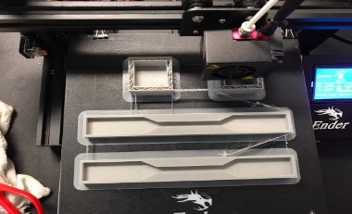
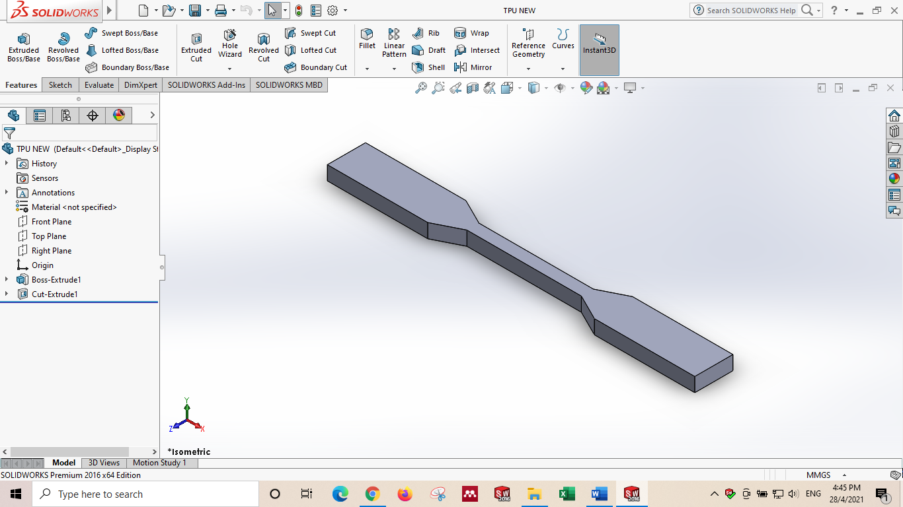
(a) (b)
Fig. 1. Figure 1a) showed the designation of the test specimens for the TPU tensile test. Figure 1b) depicts the printing process for the molds of the tensile and compression test for the silicon materials
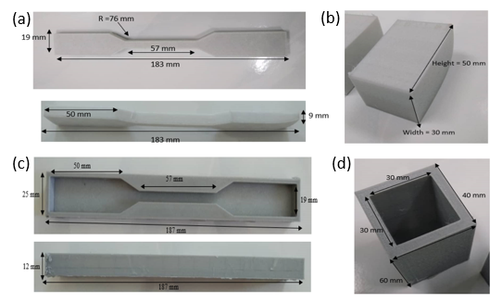
Fig. 2. Figure 2a) depicts the specifications of the tensile test for the TPU materials. Figure 2b) showed the specifications of the compression test for the TPU materials. Figure 2c) and 2d) depicts the molds for the silicon materials specifications
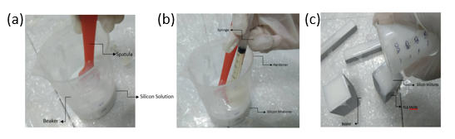
Fig. 3. Figure 3a) shows the silicon solution was stirred completely before the mixing process to ensure the solution was even in viscosity. Figure 3b) depicts the hardener solution that was poured into the beaker that contained the silicon solution based on the ratio of three percent of hardener to the total volume used for the silicon solution. The mixture was then stirred for about five minutes to blend them well. Figure 3b) showed the silicon mixtures were poured into the molds to obtain the desired shapes for the test samples.
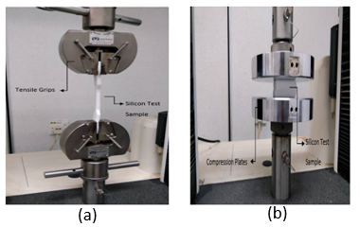
Fig. 4. Figure 4a) showed the tensile load was exerted on the test samples. Figure 4b) showed the compression load was applied on the silicon samples

Table 2. Mechanical Properties of the RTV Silicon Materials
Characteristics | Value
Base Viscosity | 24,000 cP
Density | 1.18 g/cc
Tear Resistance | 17/Nmm
Hardness | After 72 hours 21 -+ 2 shA
Strength Resistance | 3/Nmm2
Elongation at Break | 400 %

The TPU test samples were extruded from the TPU filaments at room temperature to gain the specific test specimen as illustrated above. The TPU samples utilized about 100 grams approximately of TPU filaments per test samples printed. The fabrication of the silicon samples used about 100 grams of silicon mixtures per test specimens and cured at room temperature for 24 hours.

  - Tensile and Compression Test
The tensile and compression test were carried out by employing an Instron 300K machines with a speed of 20 mm/min at the room temperature surroundings. The tensile samples were first marked with a marker to calibrate the tensile grips and the test specimen length. The samples were tested until achieved the breaking point (completely tear). The data was then collected using the Instron software and tabulated as in table 3 and table 5 below. Figure 4a) depicts the tensile test for the silicon samples. Next, the compression test was conducted by applying for the parallel compression plates. The rectangular samples were then pressed until the maximum height of extension for the samples achieved.
  - Hardness Test
Hardness test is one of the methods that had been used in this experiment to measure the material’s comprehensive performance reaction especially in the ability of the materials to withstand the resistance and to determine the elasticity of the materials. A digital shore durometer (type A) was utilized for measuring the hardness of the TPU and silicon materials. The durometer type A instrument is suitable for medium hardness rubber such as plastic, rubber, leather, multi-grease, wax, and others. The range measured for the durometer instrument was varied from 0 HA to 100 HA. The higher the HA values, the higher the hardness of the material tested. By following the guidelines from ASTM D2240, a sample of the TPU and silicon materials were prepared respectively before the experiments were conducted. The sensing pin that resembles needle-like stuff was penetrated the materials by a constant force and created resistance force from the samples that generated the hardness values for each of the samples [22].

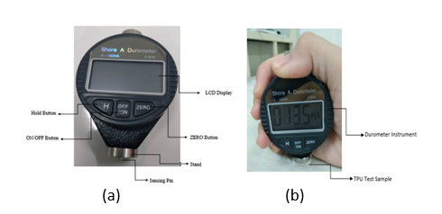
Fig. 5. Figure 5a) shows the mechanism of the Durometer device. Figure 5b) demonstrated the application of the Durometer device for measurement activities
- Results and Discussions
  - Strength of Material

TPU Material
The results of the tensile test for the TPU materials were recorded and tabulated into the graph and table 3 below. Three identical samples of the TPU materials were analyzed and merged into the same graph to obtain a comparison of the graph trends during the experiments. In figure 6, the sample 1 and sample 3 achieved almost the same correlation values with the extension of the TPU test samples achieved 400 mm respectively. The trends of both samples 1 and 3 were increasing significantly that demonstrated the elongation process occurred during the extension process of the samples before reaching the breaking point and dropped values that reached almost 400 N for both of the samples respectively. However, samples 2 displayed an odd shape of the graphs compared to samples 1 and 3. Sample 2 managed to achieved tensile extension at 170 mm approximately which is less than sample 1 and 3 results. Furthermore, sample 2 also conveyed 320 N of load approximately which showed a huge difference in the load values compared to samples 1 and 3. The irregular shapes at the end of the dropped values of the test samples 2 represented there was a continuous extension of the material even after the breaking point of the material was portrayed. These samples have different values and trends due to the different stress distribution for each of the specimens. Sample 1 and 3 were completely broken during the experimental process at the center point of the dog-bone specimens while sample 2 breaks at the end radius of the specimens. These situations may happen because of the distinct load from the tensile grips that were exerted on the specimens and the inconsistency of the filled volume of the TPU specimens after the printing process that lead to the dissimilar stress distribution of the tensile specimens.
From the figure 6a), Hookean behavior were founded at the early stage of the tensile test. The linear elastic properties then changed to viscous behavior in the middle of the experiments with the additional load observed. In this phase, the stress and strain relationship were directly proportional. As the load exceeded the limitation of the TPU material, the TPU flex exhibit plastic behavior and finally break with permanent damage were recorded. Meanwhile, figure 6b) form the viscoelastic behavior where the material return to their original shapes after the load was removed.
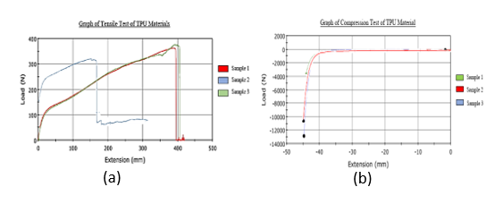
Fig. 6. Figure 6a) showed the graphs of tensile load versus the tensile extension of the TPU materials. Figure 6b) depicts the compression load versus compression extension
Table 3. The Tensile Test Results of the TPU Specimens
 | Tensile Strain at Maximum Tensile Extension (mm/mm) | Load at Maximum Tensile Extension (N) | Modulus (Automatic) (MPa)
Sample 1 | 2.29 | 2.22 | 3.29
Sample 2 | 1.67 | 68.20 | 8.23
Sample 3 | 2.26 | -1.04 | 3.18

Table 4. The Compression Results for the TPU Material
 | Minimum Load (N) | Time at Minimum Load (sec) | Energy at Minimum Load (J) | Extension at Minimum Load (mm)
Sample 1 | -3, 532.19 | 134.22 | 8.43 | -44.74
Sample 2 | -10,592.03 | 137.00 | 17.48 | -45.66
Sample 3 | -12,776.37 | 106.71 | 18.73 | -45.24

Silicon Material
The tensile test for the silicon material demonstrated similar increasing trends of extension due to the elastomeric properties of the silicon material before reached the breaking points where the tensile load values plummeted to zero values. The tensile strain at maximum tensile extension for samples 1, 2, and 3 were 1.37 mm/mm, 1.55 mm/mm, and 1.35 mm/mm respectively. The load at maximum tensile extension for sample 1 was -1.30 N, sample 2 was -0.91 N and sample 3 was -1.08 N. The automatic modulus analyzed were 0.68 MPa for both samples 1 and 2 while sample 3 showed slightly high values with 0.89 MPa.

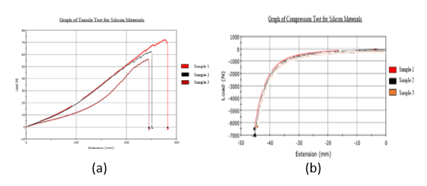
Fig. 7. Figure 7a) showed the graph of tensile load versus tensile extension for silicon materials. Figure 7b) depicts the compression load versus compression extension for the silicon materials
Table 5. The Tensile Test Results for the Silicon Materials
 | Tensile Strain at Maximum Tensile Extension (mm/mm) | Load at Maximum Tensile Extension (N) | Modulus (Automatic) (MPa)
Sample 1 | 1.37 | -1.30 | 0.68
Sample 2 | 1.55 | -0.91 | 0.68
Sample 3 | 1.35 | -1.08 | 0.89

The graphs in figure 7 illustrated the corresponding trends for all of the test samples where the compression extension results were decreased due to the force exerted on the specimens. Similar trends for the compression test as in the figure 6b) were observed in the figure 7b) where the silicon specimens underwent viscoelastic phase that enable the material to rebound back to the original length and shape with minimum exerted load recorded was 6,000 N approximately and compressed until 90 percent of the height of the sample. Based in table 6, the silicon material required less load compared to the TPU material in table 4 values with almost twice load values. However, the energy generated at minimum load of the silicon were twice of the TPU material. Therefore, from these results we can deduce that the TPU material have twice strength compared to the silicon material but at the other side, the silicon demonstrated twice elasticity than the TPU material due to the ability of the silicon to absorb force from the applied load.
Table 6. The Compression Results for the Silicon Materials
 | Minimum Load (N) | Time at Minimum Load (sec) | Energy at Minimum Load (J) | Extension at Minimum Load (mm)
Sample 1 | -6,464.43 | 135.91 | 34.60 | -45.30
Sample 2 | -6,859.55 | 135.73 | 36.63 | -45.24
Sample 3 | -6,029.81 | 135.98 | 33.01 | -45.33
  - Material Hardness
The hardness of the materials can be measured through the hardness test by using the Durometer shore A device that utilizes the indentation method to calibrate the elasticity and the durability of the following materials. In table 7, three distinct points of a single test specimen were used to determine the average values of the TPU and silicon materials. The huge gaps between these two materials depicted that the TPU materials were way too hard compared to the silicon materials. This relationship suggested that the increase the shore values, the harder the material hardness.

Table 7. Durometer Hardness Test for the TPU and Silicon Materials
Material | 1 | 2 | 3 | Average (HA)
TPU | 76.5 | 73.5 | 77.5 | 75.8
Silicon | 16.0 | 18.0 | 18.5 | 17.5
  - The Suitability of the TPU Flex and Silicon Material in the Fabrication of the CardioVASS Heart Model
In this research, we tried to highlight the suitability of the TPU flex and silicon material for the fabrication of the CardioVASS heart model by studying the mechanical properties of the materials respectively. The research conducted by Mohd Adib et. al., [19] and Khairul et. al., [23] had implemented TPU flex shore 85 A materials for the manufacturing of their heart model. Based on their research, they had successfully constructed a simple TPU flex heart model but with multiple limitations confronted such as the difficulties in adjusting the strength and flexibilities of the model. Aiming to fabricate a functional heart model with good flexibilities and mimicking the actual heart, our CardioVASS project tried to solve the problems related to the heart models by studying the mechanical properties of the model to identify the strength and weaknesses of each of the material selected as in this paper. Previously, the TPU flex shore 85 A was tested and compared with the soft epoxy resin material to identify the significance of the material with the fabricated heart model [13]. The results shown that the TPU flex was able to demonstrate better elongation, flexibility and strength compared to the epoxy resin material. Table 8 below demonstrated the extracted data from previous experimental for the TPU flex material. A comparison between the TPU flex material was presented as in figure 8 below. The sample labelled 4, 5, and 6 were the samples from last experimental showed almost regular shapes and trends that in contrast with the sample 1,2, and 3 that conducted in this experiment. Based on the observation from figure 8, TPU flex experienced longer extension of samples mainly because different TPU shore hardness was used and difference setting of the values of the 3D printer temperature was deployed. The maximum modulus gained for the TPU flex shore 85 A was 13.78 MPa that almost multiple of the maximum modulus results for the TPU flex shore 95 A with 8.23 MPa as in the table 3 above. The values may vary due to the design implementation, infill, layer, thickness and temperature setting during the extrusion of the samples. The shore hardness of the TPU material also may dropped during the extrusion process as represented in table 7 where the average shore hardness dropped to 75.8 HA compared to the actual TPU flex filament, 95 HA. Richard et.al., [24] in his research mentioned that the polyurethanes was among the most feasible type of polymer for the heart valve applications that manage to achieve several hundred million cycles during the in vitro durability testing. Recent studies demonstrated by Takaya Hoashi et.al., [25] had successfully constructed 20 custom made 3D printed heart model for preoperative surgical simulations to treat the congenital heart disease by utilizing the polyurethanes resins materials. The findings demonstrated that polyurethane resins can be recognized as having potential utility, particularly in understanding the relationship between intraventricular communications and great vessels, as well as in simulation for creating intracardiac pathways. Thus, we can deduce that the TPU material was capable to be fabricated as heart model due to the excellent elastomeric properties. However, the application of the TPU material for the fabrication of the heart model itself was not enough due to the insufficient strength and strain properties of the heart model prototypes and many researchers tried to solve the problems by mixing the polyurethanes materials with other polymer and materials to enhance their current properties [ 26-27].
Table 8. Mechanical Properties for the TPU Flex [13]
 | Modulus (Automatic Young’s Modulus) [MPa] | Tensile Stress at Tensile Strength [MPa] | Tensile Stress at Break Standard [MPa] | Force at Tensile Strength [kN]
Sample 4 | 13.78 | 2.31 | 0.02 | 0.31
Sample 5 | 11.57 | 2.32 | 0.01 | 0.31
Sample 6 | 12.07 | 2.34 | 0.01 | 0.31

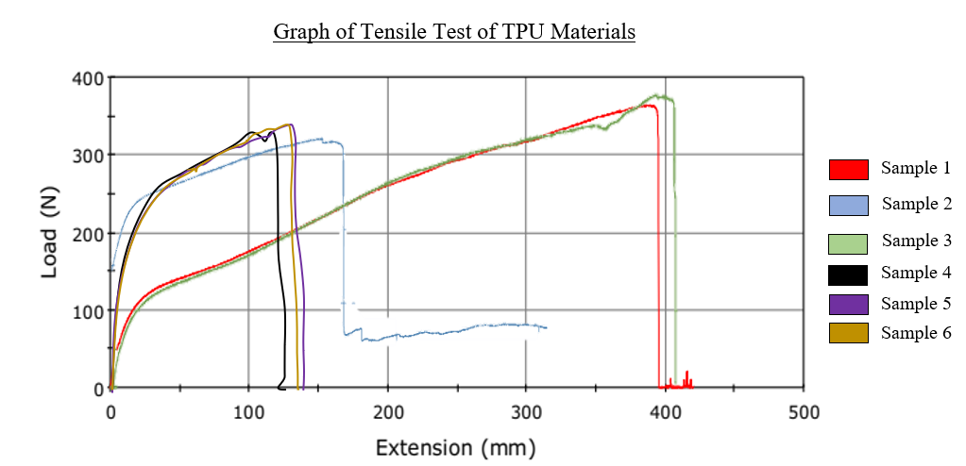
Fig. 8. Figure 8 demonstrated graph of tensile test versus extension for the TPU flex material

Silicones material or known as siloxane was also one of the feasible types of polymer material that had used widely in manufacturing field, especially in the medical region. In this paper, the tensile and compression test had demonstrated that the silicone material was twice weaker in strength compared to the TPU material. However, the hardness test revealed that the silicone was four times weaker in terms of mechanical hardness shore. While hardness is dependent on ductility, elastic stiffness, plasticity, strain, strength toughness viscoelasticity and viscosity [28] of a material, it is understandable that there was some contradiction between the ratios as distinct mechanical test were conducted. On the contrary, because of the composition of silicon which allows free rotation along the chain, the silicone exhibits more elasticity than the TPU as described earlier in section 3.1, resulting in high polymer flexibility [29]. Nicholas [29] in his research had highlighted the application of the silicone elastomers for the fabrication of the artificial hearts agreed that the silicone elastomer was suitable for the soft artificial heart development because of the softness properties of the silicone itself. He also mentioned that the past artificial heart was commonly rigid due to the material properties constraint. The softness from the silicone was desirable as it can biomimicking the actual heart physiological blood flow and pumping.
In short, both TPU and silicon material demonstrated high potential to be developed as heart model for the CardioVass device. However, the materials still restricted to some weaknesses especially in strength, durability and elasticity compared to the actual heart. Improvement for both of the material were expected in the future for better heart model making.
  - Limitations
There were some limitations founded in this research. To begin with, the present work only represented a single type of polymer, RTV silicone and TPU flex shore 95 A only. By using a wide range of elastomeric polymer studies, we can make more strength and flexibilities comparison regarding the mechanical properties of the selected material. Next, the method that had been conducted to fabricate the samples were restricted to the FDM 3D printer only for the TPU flex material and curing process method for the RTV silicon. A better and compromise results expected when utilizing an advanced method in the fabrication process. For instance, using the stereolithography (SLA) and digital light projector (DLP) method that can produce a flexible and precise model sample with the complex geometries. Lastly, there was no addition of distinguished materials were presented in this work compared to the other research that known can establish the mechanical properties of the elastomeric materials especially. High scale of research must be done to study the most suitable material that can merge with the existing selected material that can improvise the mechanical properties of the material.
- Conclusions and Recommendations
In conclusion, the tensile and compression test validate that the TPU and silicon materials were able to demonstrate high strength and elasticity although have a soft structure of materials. Regardless, to achieve the actual heart strength, the TPU flex and RTV silicone strength were way too low in strength and durability. The results pointed out that the TPU material was twice higher in strength compared to the silicon material. In contrast, the silicon material was twice elastic than the TPU material. Here, we can conclude that both of the materials were capable to be fabricated as heart model for the CardioVASS device but the TPU materials were preferred as the material have better strength, elongation, and durability compared to the silicon material. However, the softness properties from the silicone material was desirable for the development of the heart model due to the natural properties of silicon that biomimicking the actual heart. With the vast types of polymer, there still some room for the improvement for improvising the current mechanical properties of the material by merging different types of polymers or material and changing the method of material manufacturing by using advanced technological machine for 3D printing such as SLA printer. In the future, more research and development must be carried out to improvise the mechanical properties of the selected materials so that we can obtain an excellent heart model that can initiate the revolution of the local heart model in the market.

Acknowledgement. The support from the Ministry of Higher Education under PRGS grant PRGS/1/2019/TK03/UMP/02/4, UMP under grant RDU190805 and PGRS2003198 and Medical Engineering & Health Intervention Team (MedEHiT) are gratefully acknowledged.

References
- S.H. Su, Z.K. Hua, J.H. Zhang.: Design and mechanics simulation of bionic lubrication system of artificial joints, J. Bionic Eng. 3, 155-160 (2006).
- S. Bondurant, V. Ernster, R. Herdman.: C.S.S.B. Implants, I. Medicine, Safety of Silicone Breast Implants, National Academies Press, Washington, USA, (2000).
- C. Goudie, A. Gill, J. Shanahan, A. Furey, A. Dubrowski.: Development of an Anatomical Silicone Model for Simulation-based Medical Training of Obstetric Anal Sphincter Injury Repair in Bangladesh. Cureus (2019).
- A. Barton.: Medical adhesive-related skin injuries associated with vascular access: Minimising risk with Appeel Sterile. British Journal of Nursing. 29, S20–S27 (2020).
- T. Swift, G. Westgate, J. Van Onselen, S. Lee.: Developments in silicone technology for use in stoma care. British Journal of Nursing. 29, S6–S15 (2020).
- E. P. Barboza, G.O. dos Santos, C. Montez, L.A. Sendra, E. de O. Vieira, W. Carvalho,V.F. Ferreira.: Evaluation of Surgical Gown Textiles for Resistance Against Aerosols: A Preclinical Double-Blind Study. Frontiers in Dental Medicine. Vol. (2), Article 654911 (2021).
- X. Li, K. H. Koh, M. Farhan, K. W. C. Lai.: An ultraflexible polyurethane yarn-based wearable strain sensor with a polydimethylsiloxane infiltrated multilayer sheath for smart textiles. Nanoscale. 12, 4110–4118 (2020).
- Q. Chen, Y. Li, D. Xiang, Y. Zheng, W. Zhu, C. Zhao, H. Li, H. Han, Y. Shen.: Enhanced Strain Sensing Performance of Polymer/Carbon Nanotube-Coated Spandex Fibers via Noncovalent Interactions. Macromolecular Materials and Engineering. 305 (2020).
- Y. Poojari.: Silicones for Encapsulation of Medical Device Implants. Silicon, 9(5), 645–649 (2017).
- X. Zhang, D.S. Brodus, V. Hollimon, H. Hu.: A brief review of recent developments in the designs that prevent bio-fouling on silicon and silicon-based materials. Chemistry Central Journal. BioMed Central Ltd, 11(1),18 (2017).
- M. Rahaman, W. Xiao.: Silicon nitride bioceramics in healthcare. International Journal of Applied Ceramic Technology, 15(4), 861–872 (2017).
- S-B. Yeh, C-S. Chen, W-Y. Chen, C-J Huang.: Modification of silicone elastomer with zwitterionic silane for durable antifouling properties. Langmuir 30(38),11386–1139 (2014).
- N.A.K. Rosli, M.A.H.M. Adib, N.N.M. Sukri, I.M. Sahat, N.H.M. Hasni.: The CardioVASS Heart Model: Comparison of Biomaterials between TPU Flex and Soft Epoxy Resin for Biomedical Engineering Application, 2020 IEEE-EMBS Conference on Biomedical Engineering and Sciences (IECBES), 2021, 224-229 (2020).
- D.J. Chauvel-Lebret, P. Auroy, M. Bonnaure-Mallet.: Biocompatibility of elastomers, in: S. Dumitriu (Ed.), Polymeric Biomaterials, Revised and Expanded, Taylor & Francis, 311-360 (2011).
- J.M. Wasikiewicz, N. Roohpour, P. Vadgama.: Packaging and coating materials for implantable device, in: A. Inmann, D. Hodgins (Eds.), Implantable Sensor Systems for Medical Applications, Woodhead Publishing Limited, Oxford, UK, 68-107(2013).
- M.A. H. M. Adib, N. H. M. Hasni.: Study the heart valve elasticity and optimal of vortex formation for blood circulation measurement on the left ventricle using the heart simulator (Heart-S) apparatus, in ACM International Conference Proceeding Series, 58–62 (2017).
- L.Q. Liang, K.Y. Hui, N.H M. Hasni, M.A.H.M. Adib.: Development of heart simulator (heart-S) on the left ventricle for measuring the blood circulation during cardiac cycle, J. Biomimetics, Biomater. Biomed. Eng., vol. 36, 78–83, (2018).
- N.A.K. Rosli, M.A.H.M. Adib, N.H.M. Hasni, M.S. Abdullah.: Effect of hemodynamic parameters on physiological blood flow through cardiovascular disease (CVD) - The perspective review. Journal of Advanced Research in Fluid Mechanics and Thermal Sciences. 74, 19–34 (2020).
- M.A.H.M. Adib, K.S.A. Yakof, Z. Anuar, N. Abdullah, I.M. Sahat, N.H.M. Hasni.: The cardio vascular simulator (CardioVASS) device on monitoring the physiology of blood flow circulation via angiographic image for medical trainee, J. Adv. Res. Fluid Mech. Therm. Sci., 62(1) (2019).
- E3-95.: Standard Practice for Preparation of Metallographic Specimens, ASTM Int., vol. 82, no. C, 1–15, (2016).
- Tractus3D. https://tractus3d.com/materials/tpu, last accessed 2020/8/30.
- S. Sharma, J. Singh, H. Kumar, A. Sharma, V. Aggarwal, A.S. Gill, N. Jayarambabu, S. Kailasa, K. V. Rao.: Utilization of rapid prototyping technology for the fabrication of an orthopedic shoe inserts for foot pain reprieve using thermo-softening viscoelastic polymers: A novel experimental approach. Measurement and Control 53(3), 519-530 (2020).
- K. S. A. Yakof, N. F. Zabudin, I. M. Sahat, and M. A. H. M. Adib, “Development of 3D printed heart model for medical training,” in Lecture Notes in Mechanical Engineering, vol. 0, no. 9789811087875, Pleiades Publishing, 109–116 (2018).
- R. L. Li, J. Russ, C. Poschalides, G. Ferrari, H. Waisman, J. W. Kysar, and D. Kalfa, “Mechanical considerations for polymeric heart valve development: Biomechanics, materials, design and manufacturing,” J. Biomaterials 225,119493 (2019).
- T. Hoashi, H. Ichikawa, T. Nakata, M. Shimada, H. Ozawa, A. Higashida, K. Kurosaki, S. Kanzaki, and I. Shirashi.: Utility of a super-flexible three-dimensional printed heart model in congenital heart surgery. In: 31st Annual Meeting of the European Association for Cardio-Thoracic Surgery, Vienna, Austria (2017).
- A. Kobuszewska, D. Kolodziejek, M. Wojasinski, E. Jastrzebska, T. Ciach, Z. Brzozka.: Lab-on-a-chip system integrated with nanofiber mats used as a potential tool to study cardiovascular diseases (CVDs). Sensors and Actuators, B: Chemical, 330 (2021).
- Z-W. Tao, S. Wu, E.M. Cosgriff-Hernandez, J.G. Jacot.: Evaluation of a polyurethane-reinforced hydrogel patch in a rat right ventricle wall replacement model. Acta Biomaterialia, 101, 206–218 (2020).
- G. Barker.: The Engineer's Guide to Plant Layout and Piping Design for the Oil and Gas Industries. Gulf Professional Publishing, (2018).
- N.H. Cohrs.: Silicone Elastomers for Artificial Hearts: 3D-Printing, Bioactive Glass and Potential. ETH Zurich, Germany (2018).

